041008 Quiz 2 XRD

When an x-ray beam passes through a crystalline sample, part of the beam, about 1%, is scattered (diffracted), part of the beam is transmitted and part is absorbed.

a) Sketch a graph of how you think the intensity transmitted, I, would change as a function of sample thickness, t, and give an equation that describes the plot.

b) If a sample is doubled in thickness the number of crystallographic planes that give rise to diffraction from a transmitted beam double. Use this fact and your answer to part a to propose a sketch of how you think diffracted intensity would change with sample thickness and use this model to derive an equation for the optimum sample thickness for a transmission experiment.

c) What is the transmission ratio, I/I₀, for such a sample of optimal thickness?

d) Explain the association between the absorption edges of an attenuator and the characteristic emission lines of an x-ray tube using the Bohr atomic model (electron orbitals of quantized energy) (http://zebu.uoregon.edu/~js/glossary/bohr_atom.html).

e) When charged particles change momentum (stop motion or change path) they emit radiation and lose energy (such as in a synchrotron or in an x-ray tube). Bohr used this fact to critique the Rutherford model for an atom which involved electrons orbiting a positively charged nucleus. Explain in your own words the problem with a model based on electrons orbiting the nucleus. (Bohr's alternative quantum model was later shown consistent with Heisenberg's uncertainty principle).

ANSWERS: 041008 Quiz 2 XRD

a)
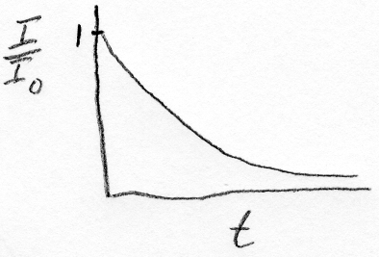

I/I₀ = exp(-μ x).

b)
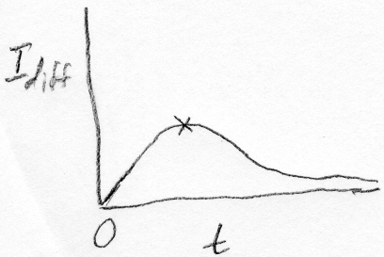
I_{diffraction} = x I₀ exp(-μ x)
Find the maximum by setting the first derative to 0.
exp(-μ x*) -μ x* exp(-μ x*) =0
so
x* = 1/μ

c) I/I₀ = 1/e = 0.37 (37%)

d) Both absorption edges and the characteristic emission lines are associated with ejection of an electron from the lowest energy K orbital. In absorption the ejection is the result of an x-ray photon which creates a photoelectron emission and in the case of the characteristic emission lines an electron with energy larger than the K orbital energy impacts the atom and leads to ionization followed by the decay of an L or M orbital electron to the lower energy K orbital with the emission of a photon of the characteristic energy associated with the energy difference between the L or M orbital and the K orbital (K_{α} and K_{β} x-rays).

e) An electron traveling in an orbit would emit x-rays because the electron momentum would be constantly changing just as an electron in a synchrotron emits x-rays due to the curved path. The first problem is that this does not happen, i.e. most atoms are not radioactive. Secondly, the loss of energy by emission of x-rays would slow the electron making it decay towards the nucleus in a continuous fashion until the electron combined with the protons in the nucleus and the atom collapsed. This is also contrary to observation; that is most atoms exist for long periods of time in a stable state. There is no evidence that supports an atomic model of electrons orbiting a nucleus. Bohr proposed electrons displaying a fixed and naturally determined energy level, the Bohr "orbital", i.e. K, L, M etc. "orbitals". The orbitals have an exact energy and the Heisenberg uncertainty principle states that if the energy is know exactly, the position can not be known, then emission of x-rays is not allowable since the emission would have a direction indicating the position of the electron which emitted the photon. The Bohr model is completely self-consistent and consistent with observation but the model defies somewhat a logical description. It results in the idea of electron "clouds" surrounding the nucleus which are described as a probability envelope for the location of the electrons. The electrons have a quantized (fixed) energy but do not really orbit. In many ways the electrons in atomic orbitals are better understood as waves rather than particles.

