041104 Quiz 6 XRD

a) Sketch a generalized diffraction experiment with an incident unit vector (beam) S₀ a sample and a diffracted beam S as well as the angle 2θ. Show how this sketch can be used to create the Ewald construction. In the Ewald sketch indicate the origin of reciprocal space by the point O.

b) In the Ewald construction where is the x-ray detector from the diffraction experiment?

c) Explain how rotation of the Ewald sphere, to create the limiting sphere, can represent a powder pattern measurement. (you will have to redraw the Ewald construction with the reciprocal lattice including its origin and show how random orientation of the diffractometer with respect to the crystal can be achieved.)

d) Explain, using the Ewald construction, the patterns seen in the forward and in the back-reflection Laue patterns from the lab.

e) The photon momentum vectors S and S₀ have magnitudes of h/λ where h is Planck's constant. Ignoring the constant, h, calculate S-S₀, the momentum change vector for the diffraction measurement. (This is completely analogous to an elastic collision between a pool ball and a pool table bumper.) Knowing that the momentum change vector must hit a reciprocal lattice site (the Laue condition), derive Bragg's law for the (100) reflection of a simple cubic lattice by setting S-S₀ equal to the magnitude of b₁.

ANSWERS: 041104 Quiz 6 XRD

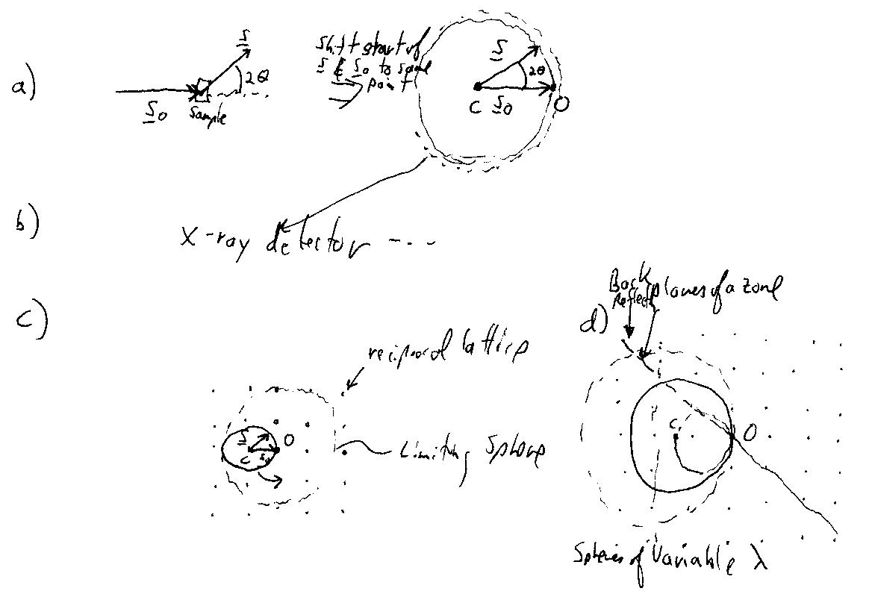
c) If all rotations of the Ewald sphere are allowed, the intersection of a lattice point on the surface of the Ewald sphere traces out a circle about the origin of reciprocal space, O. Concentric rings for different reflections result.

d) Planes of a zone are points along a plane in reciprocal space. Variable incident wavelength means variable diameter Ewald spheres that allow intersection with all of the points on this plane. The plane intersects the Ewald sphere in an ellipsoid in the forward direction and with an outward curving hyperbola in the backward direction.

e)
