041113 XRD Quiz 7

The diffracted intensity from a crystal is calculated by assembling the contributions from substructural elements. This is done by considering that a crystal is composed of unit cells, unit cells are composed of atoms, and atoms are composed of electrons.

a) Explain how correlations (associations between elementary units) are taken into account in the atomic form factor, f, and in the structure factor, F. (You will need to 1) state what is correlated in each case, 2) sketch "f" versus 2θ and 3) describe the curve. For "F" 4) write an expression involving a sum of complex exponentials in phase angle, φ_{i}, for F and 5) explain how the terms can cancel or enhance each other).

b) Explain why the two descriptions of correlations in part "a" are different.

c) Explain the origin of the Lorentz polarization factor for unpolarized radiation, (1 + cos²2θ)/2.

d) Explain why the diffracted intensity decays with 1/r² where r is the distance between the sample and the detector.

e) Give the rules for the structure factor F² for (hkl) reflections in an FCC structure. Explain the origin of these rules.

ANSWERS: 041113 XRD Quiz 7

a) The atomic form factor describes correlations of electrons in the atom while the structure factor describes correlations of atoms in a crystal. The electrons are not regularly arranged so a featureless decay curve is seen with a value of Z at 2θ = 0.
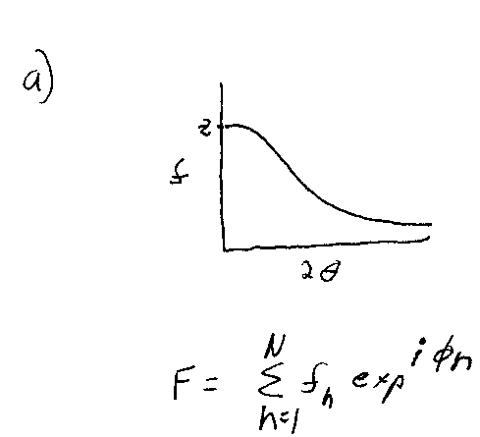
The curve decays because larger angle reflects smaller size and destructive interference occurs at small sizes where correlations between electrons become important.

If the phase angle, φ_{n}, equals π, two atoms with the same f will destructively interfere. If the phase angle equals 2π they will constructively interfere. φ_{n} can have any value and if the two atoms have different f's partial destructive interference can occur.

b) The two descriptions of correlations are different because electrons are randomly arranged while atoms in a crystal are arranged in a regular way.

c) The Lorentz polarization factor arises from the term sin²α in the Thompson factor for a free electron. α is the angle between the electric field vector in the incident radiation and the angle of detection in the diffractometer. If the detector rotates in the direction of polarization sin²α becomes cos²2θ. If the detector rotates perpendicular to the direction of polarization α is π/2 and sin²α is 1. Unpolarized x-rays are considered an average between these two cases so the sin²α term becomes (1 + cos²2θ)/2.

d) The diffracted intensity from an electron is isotropic, that is the electron "glows" in all directions like a light bulb or like the concentric rings from a rock dropped in a calm pool of water. The x-ray detector is of fixed area. If the integrated intensity of radiation from the electron is fixed then as the sphere of radiation becomes larger a fixed area on that sphere shows a decay in intensity that follows 1/r².

e) The FCC unit cell has 4 atoms at [000],[1/2 1/2 0],[1/2 0 1/2],[0 1/2 1/2]. The phase shift from [000] is given by φ_{i} = 2π (hu + kv + lw). Then,
F = f(1 + e^{iπ(h + k)} + e^{iπ(h + l)} + e^{iπ(k + l)})
If hkl are mixed (odd and even) then two of the exponentials will be odd and one will be even so the sum using Rule 1 for complex exponentials becomes (1 + 1 - 1 - 1) = 0, so F is 0, F² = 0, and the peak is absent, for example (100) or (110). If hkl are unmixed (all odd or all even) then the sum becomes (1 + 1 +1 + 1) = 4 so F is 4f and F² is 16f², for example (111) or (200).

