041203 XRD Quiz 9

Glatter (web notes) gives the following sketch to indicate scattering from flat platelets (disk). The plot shows two regions of power-law decay, I(q) = B q^{-P}, where P = 2 and
P = 4. In class we determined that all power-law scattering laws can be obtained by decomposing a structure into domains of size r and considering that I(q) ~ N(r) (V(r))² where N(r) refers to the number of domains of size r, V(r) refers to the volume of one of these domains, and r = R/q where R is a dimensionless size that is fixed at R = 1 for the decomposition.

a) For a platelet with D > r > t, show that I(q) = Bq⁻² by showing that N(r) ~ D²/r² and that V(r) ~ r²t. Sketching the platelet and domains of size r and calculate I(q) using the above equation and relationship between q, R and r.

b) For r <<< t the platelet appears to be an infinite phase with a sharp boundary so only surface scattering occurs. Show that for a flat surface, scattering will follow Porod's law, I(q) = B_{P} q⁻⁴, and that B_{P} ~ Surface Area. You will need to sketch the interface and fill it with spheres of size r, calculate N(r), V(r), I(q) and substitute r = R/q.

c) For a polymer chain in a glassy state or melt the coil size, D, is a function of the number of mer units, N, D = N^{1/2} d where d is the size of a mer unit. For D > r > d, N(r) ~ D²/r², and V(r) ~ N_{r} ~ r²/d², where N_{r} is the number of mer units in a sub-chain sphere of size r and N(r) is the number of spheres of size r in the chain. Show that I(q) ~ B_{D} q⁻² similar to platelet scaling above, where the subscript D stands for Debye who first derived this relationship.

d) The scattered intensity as a function of q is the Fourier transform of the pairwise correlation function as a function of r, γ(r). If the correlation function were a single cosine wave sketch the scattered intensity, I(q) versus q, (transform) for this single component Fourier series. (This is related to the XRD pattern from a single set of planes.)

e) The Fourier transform of a Gaussian function, γ(r) = K exp(-r²/R_{g}²) is another Gaussian function, I(q) = G exp(-q²R_{g}²/3). The latter function is called Guinier's law and is used to measure the size, R_{g} for an object. The plot above shows two Guinier regimes (dashed curves), the left for the platelet diameter and the right for the platelet thickness. For a generalized particle explain why the correlation function (probability density for two points separated by r both being in the particle phase) might display a bell shaped curve (Gaussian function) about R₀, the center of mass.

ANSWERS: 041203 XRD Quiz 9

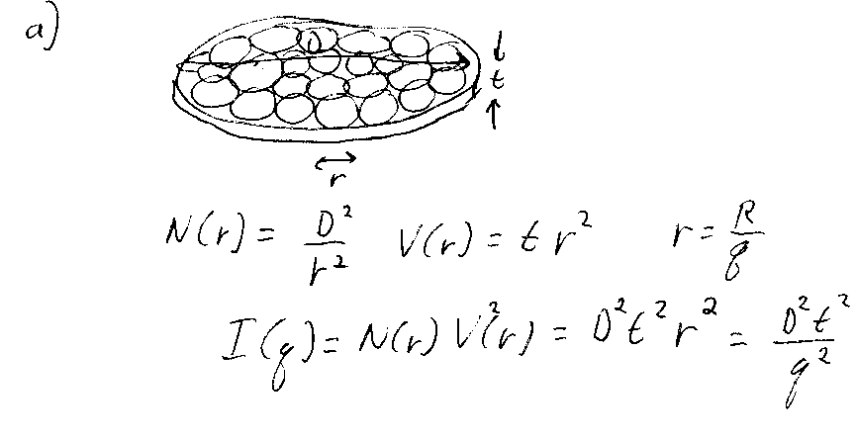

b)
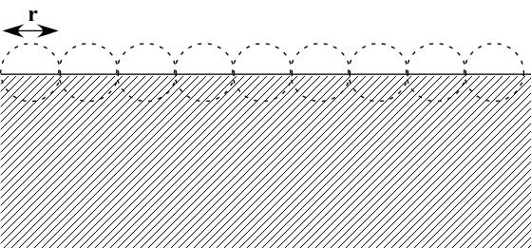

N(r) ~ S/r², V(r) ~ r³, I(q) ~ Sr⁴ ~ S/q⁴.

c) I(q) ~ N(r) (V(r))² = r²D²/d⁴ = D²/(d⁴q²) = N/(d²q²). Both the platelet and the Gaussian Coil are 2-dimensional objects that differ in connectivity.

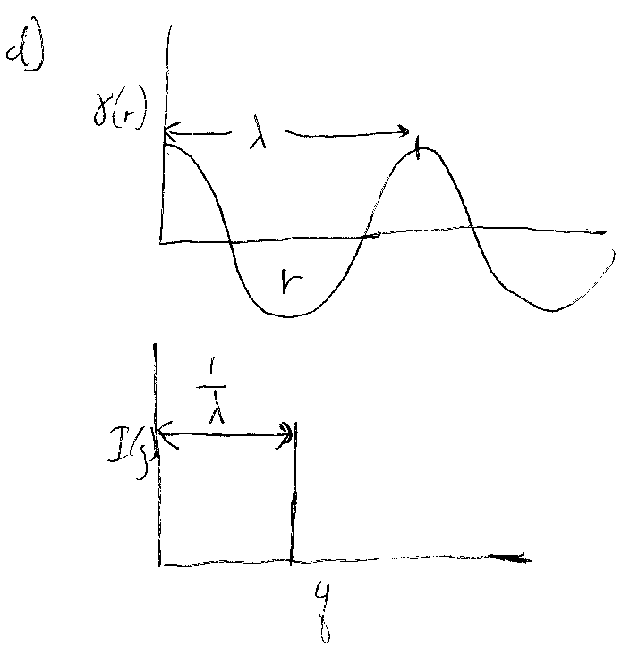

e) To calculate the correlation function we start with a point in the particle and then randomly place another point a distance r from this point and find the probability that the second point is also in the particle. This is done for all first points in the particle averaging the probabilities. Alternatively, we could consider the first point as fixed in space and spin the particle about this point summing the particle structure, then move the first point relative to the particle and sum all orientations of the particle continuing this process until all possible combinations of particle orientations are summed where two points are in the particle. This summed structure will display a bell shaped, symmetric density profile that closely follows a Gaussian function except for very large values of r. The process of summing the structure is known as the Wilson Ghost particle and is shown by Glatter in the web notes.
