Ethiopian Manufacture of Drip Irrigation Control Systems
U.S. Embassy Addis Ababa PAS Annual Program Statement PASAPSFY21
19.040 – Public Diplomacy Programs

Proposal Summary:
Drip irrigation (DI) can significantly reduce irrigation water needs, fertilizer use, and dramatically increase crop yields in some crops such as coffee, papaya, and sorghum. [1-4] It can also enable new cash crops such as fruits, vegetables and flowers. The main problem with drip irrigation is monitoring of blockages in small capillaries or holes due to dirt, and control over the irrigation and fertilization timing to optimize output. Observation of soil wetting at the surface, Figure 1, is not sufficient indication of the soil moisture at the plant roots. Sensors and control systems can dramatically improve the performance of drip irrigation systems. A drip irrigation control system includes soil moisture sensors, solar irradiance detectors, temperature, and atmospheric humidity measurements and a computer or cell phone feedback loop to operate a valve and pump system. The system can also incorporate simple algorithms to calculate the optimal irrigation and fertilization timing.
Under a Fulbright Fellowship a cell-phone operated, solar-powered soil-moisture sensor (SMS) was developed and manufactured at two Ethiopian universities as well as being field tested in Dire Dawa and Bishoftu near Addis with existing drip irrigation systems. The SMS devices were the result of a collaboration between the University of Cincinnati (UC), University of Sheffield in the UK, Addis Ababa University (AAU)/Addis Ababa Institute of Technology (AAIT) and Dire Dawa University (DDU)/Dire Dawa Institute of Technology (DDIT), Figure 1. Stem Synergy International, a US/Ethiopian NGO, proposes to use this demonstrated technology in the manufacture of complete control systems for drip irrigation in Ethiopia. It is proposed to initiate a non-profit startup located in the suburbs of Addis for the design and manufacture of drip irrigation control systems based on the Fulbright SMS devices. The proposed work will be a collaboration between Stem Synergy, Greg Beaucage at the University of Cincinnati, Max Yan and Horace McFarlane at Sheffield University, AAIT, Dire Dawa Institute of Technology, and Fair Planet, an Israeli based NGO focusing on drip irrigation in East Hararghe and Dire Dawa. Funding will be managed by Stem Synergy at their Arlington, VA office and by their Addis Ababa office and manufacturing facility.

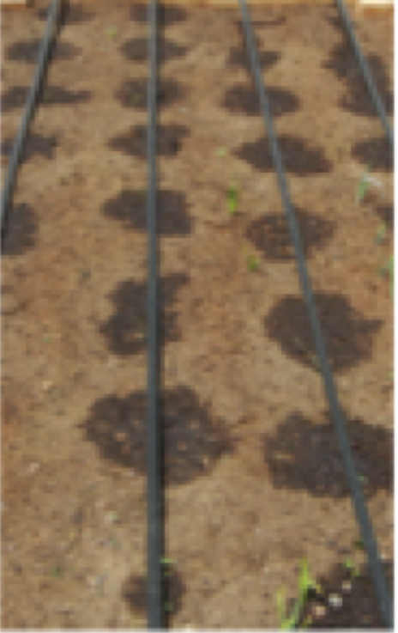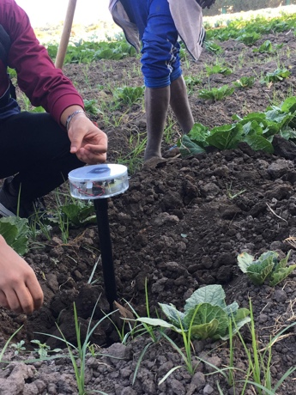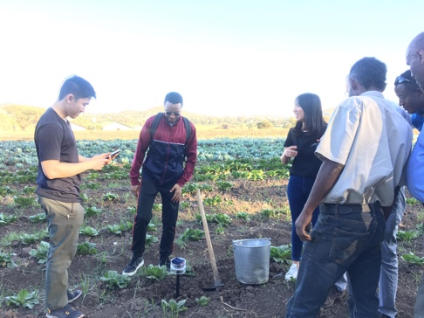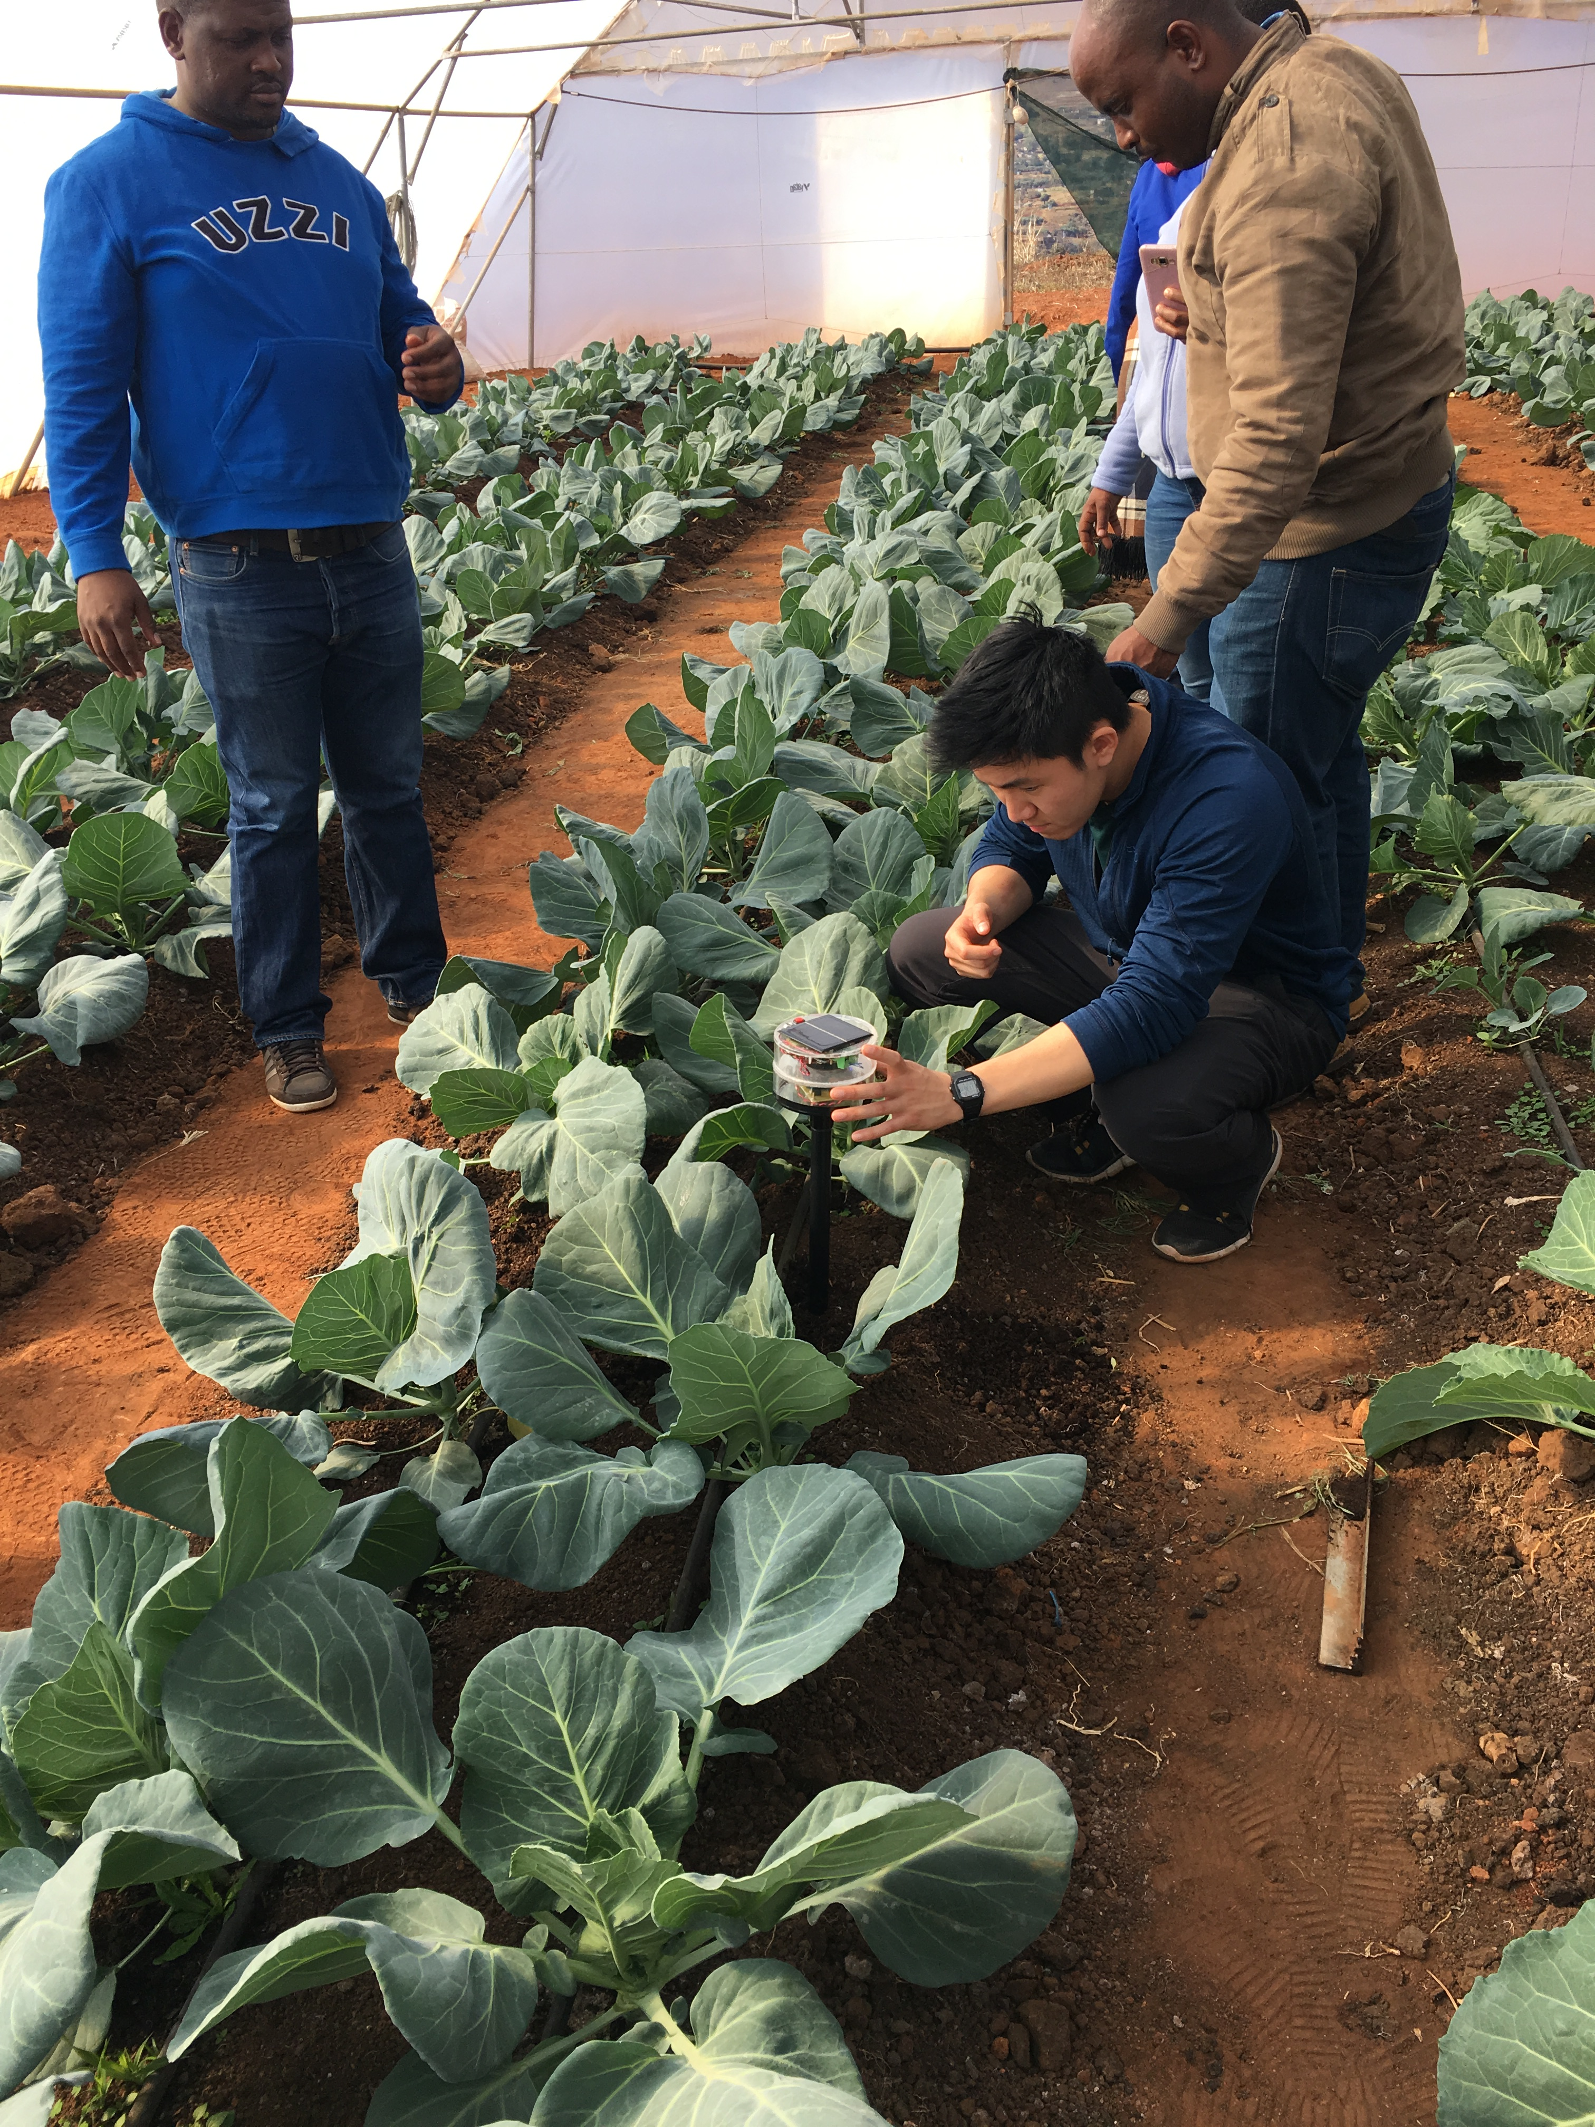

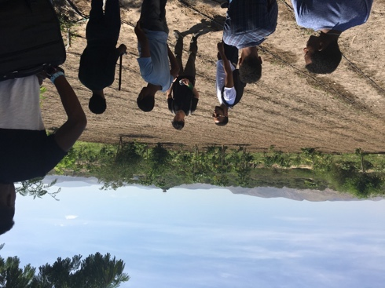
Figure 1. Field testing and assembly of soil moisture sensors. Top: Drip irrigation; sensor field tested in Dire Dawa (two images); Field test in a green house. Bottom: Field tests in Dire Dawa; AAU Bishoftu agricultural station near Addis; assembly of sensors at AAIT/AAU.

The project will be conducted over one year with:
1) Initiation of technology and manufacturing practice in Addis at Stem Synergies’ manufacturing facility;
2) Manufacture of two initial control systems for implementation in Fair Planet’s drip irrigation system and at a drip irrigation research farm operated by AAU in Bishoftu near Addis;
3) Development of a business plan and solicitation of capital investment including market development in Ethiopia;
4) Initiation of commercial production of control systems initially for cash-crop farmers near Addis taking advantage of Stem Synergies’ 22 STEM centers across Ethiopia.
At the end of one year the business is expected to employ about 5 engineers and technicians in Addis who will be responsible for design, manufacture, installation, and maintenance of the control systems. The Embassy grant will initially support two PhD engineers and one staff manager at Stem Synergy.

Introduction to the Organizations and Individuals Applying:
STEM Synergy: Stem Synergy is an NGO based in Arlington VA with activities in Ethiopia involving STEM education, Technology Transfer, and Social Enterprises. The organization has recently been awarded $380,000 by Boeing Corporation to motivate primary and secondary school students to study science and technology to solve the challenges of Ethiopia. The organization operates an annual televised national science fair. The event is reported to the public by various national media. Government officials, the scientific communities, students, parents, NGOs and diplomats attended the event. Stem Synergy operates 22 STEM Centers in Ethiopia where mentoring is conducted using a combination of system-wide curricula and local specialties. System-wide curricula includes electronics engineering, mechanical engineering, and computer skills instruction. Stem Synergy produces “STEM TV Series” to widen their reach to students living far from the Ethiopian metropolitan areas typical of the STEM Centers. The TV show has become a popular inspiration for students and their families across the nation.
Stem Synergy has recently partnered with Lytefire, a branch of a Finnish company that assists NGOs in the implementation of solar ovens. Stem Synergy is manufacturing Lytefire solar ovens in Addis with operating ovens installed for two women owned and operated commercial bakeries in Ethiopia. Stem Synergy is interested in enhancing the employment opportunities in Ethiopia for technically educated Ethiopia youth through startup companies such as in the manufacture of drip irrigation control systems in partnership with Prof. Beaucage at UC.
Greg Beaucage: Beaucage is an Engineering Professor at the University of Cincinnati who has been active in Ethiopia and other African countries for 13 years. He is the former Director of NanoPower Africa, a $5M State Department project through Higher Education for Development to provide graduate education in solar energy. NanoPower Africa was a partnership between the UC, the University of Cape Town, and four other African campuses as well as Argonne and Oak Ridge National Laboratories and several small businesses. Haramaya University (HU) and later Dire Dawa University (DDU) were involved with the project. Beaucage has been involved with collaborative technology development projects with DDU/DDIT, HU, AAU/AAIT, Mekelle University (MU) and the Ethiopian Institute of Architecture, Building Construction and City Development (EIABC). These projects involve collaboration between US undergraduate students and their peers at the Ethiopian Universities. Recently Beaucage was a Fulbright Global Scholar working in Ethiopia, UK, Lesotho and South Africa. In this Fulbright Fellowship a solar powered, cell-phone controlled soil moisture sensor was designed, manufactured at AAIT and DDIT, and field tested in Dire Dawa (in collaboration with Fair Planet) and in Bishoftu near Addis in collaboration with AAIT. Beaucage has been supported by two small grants from the Addis Embassy over the past 10 years.
In 2012 the Embassy funded $2,000 citizen diplomacy grant for expenses related to University of Cincinnati undergraduate student exchange with Haramaya University. That project involved undergraduates from HU and UC who designed and installed solar power in a medical clinic in a small village in the East Hararghe region. The same group planned for a solar well for an elementary school which was implemented the following year, Figure 2.
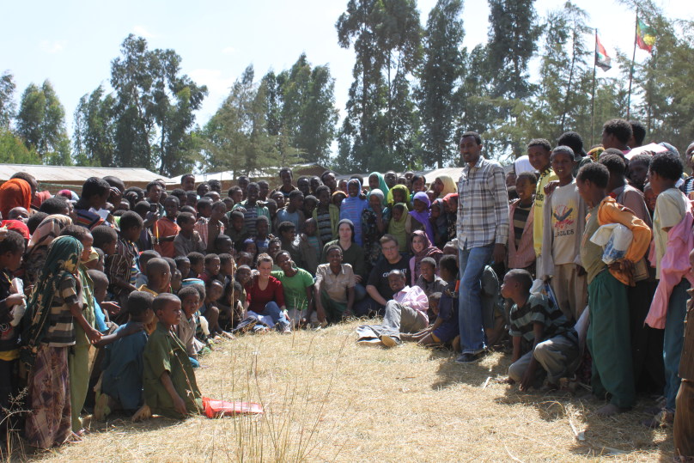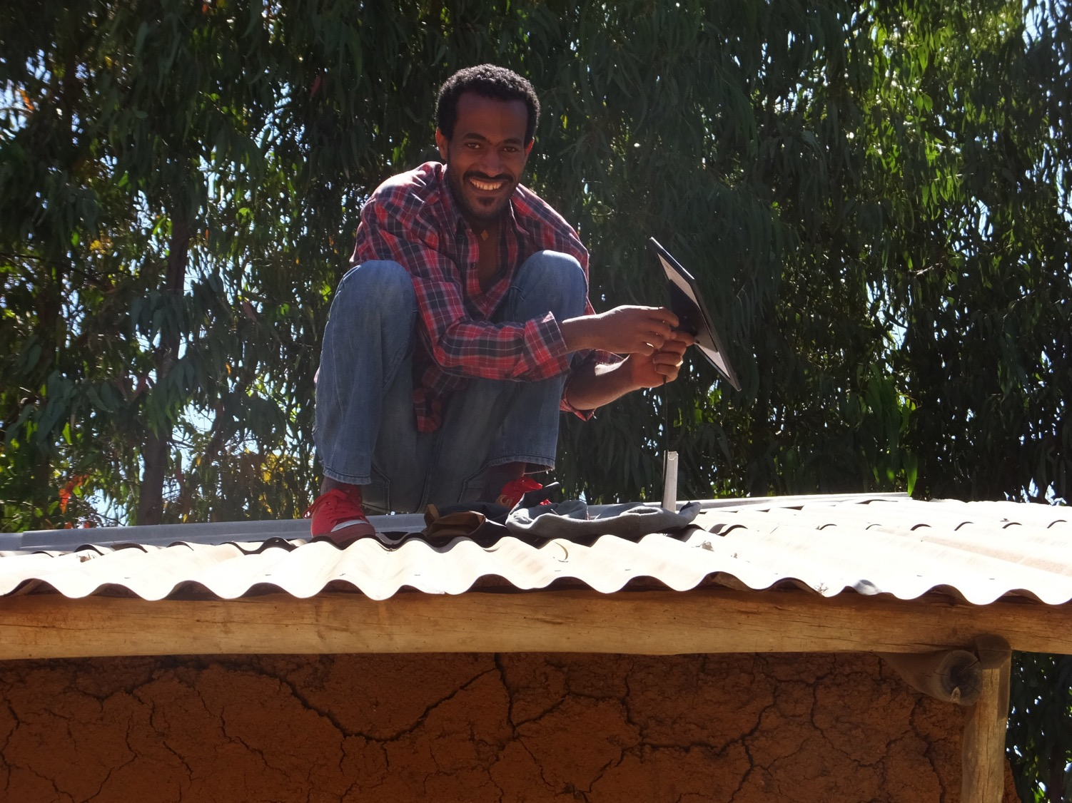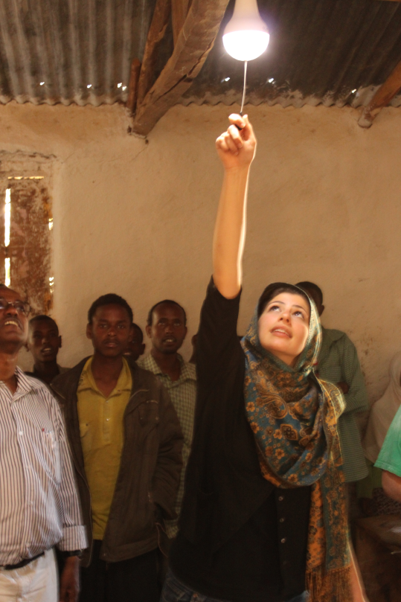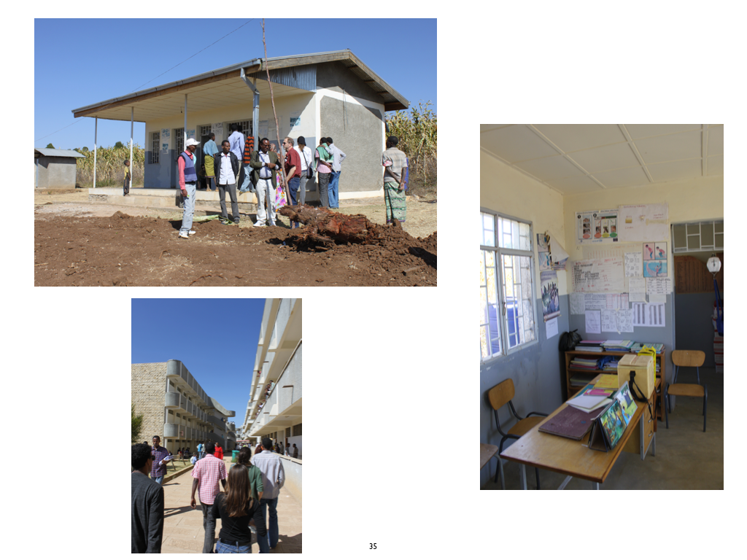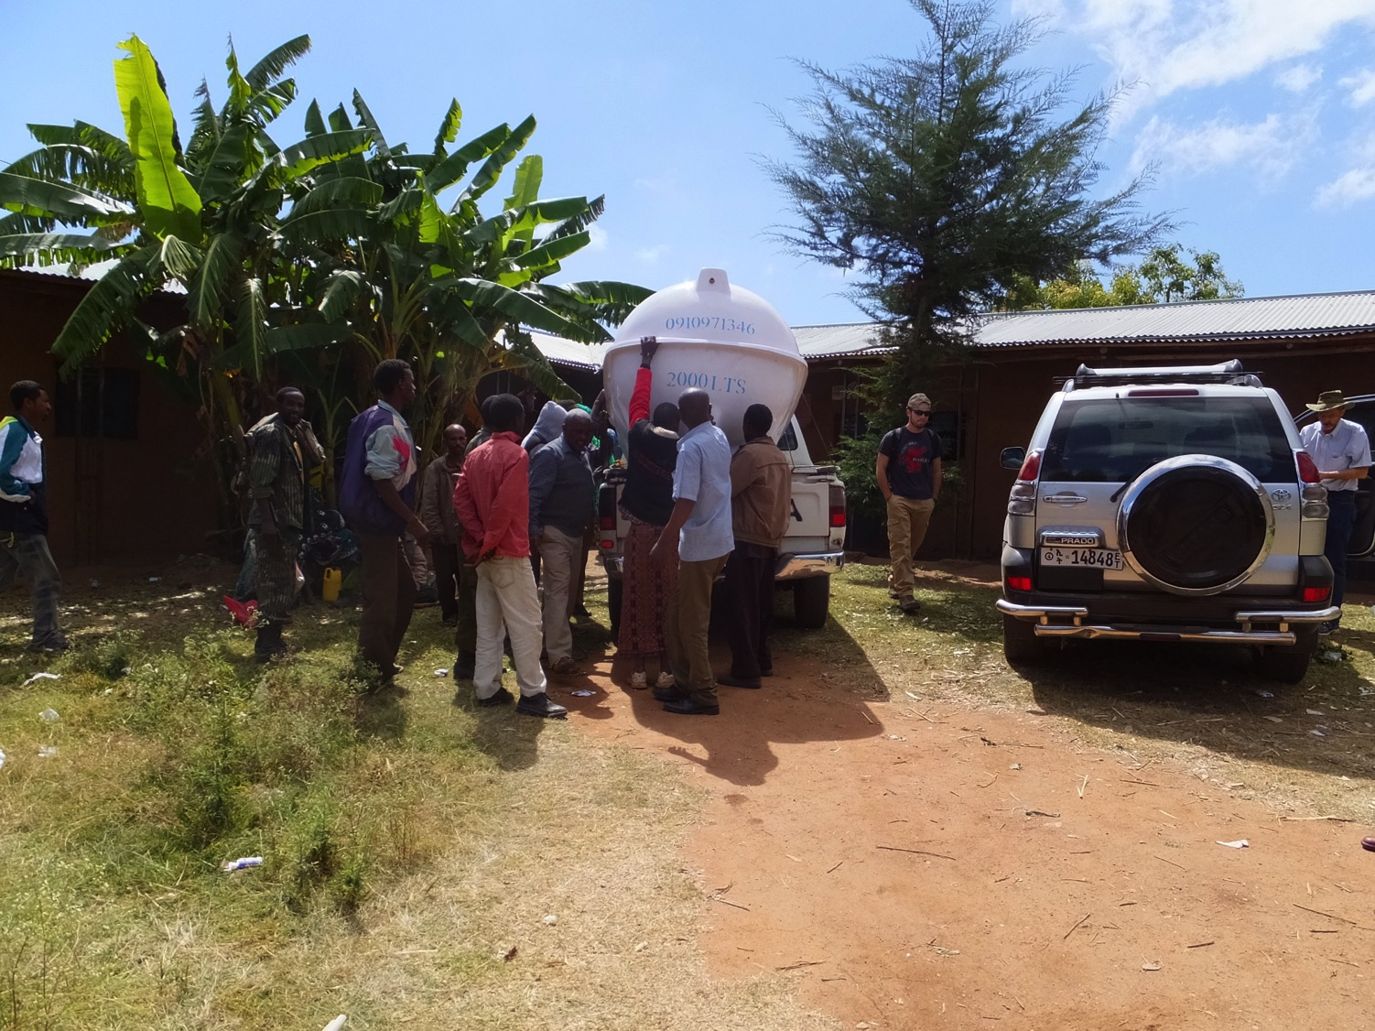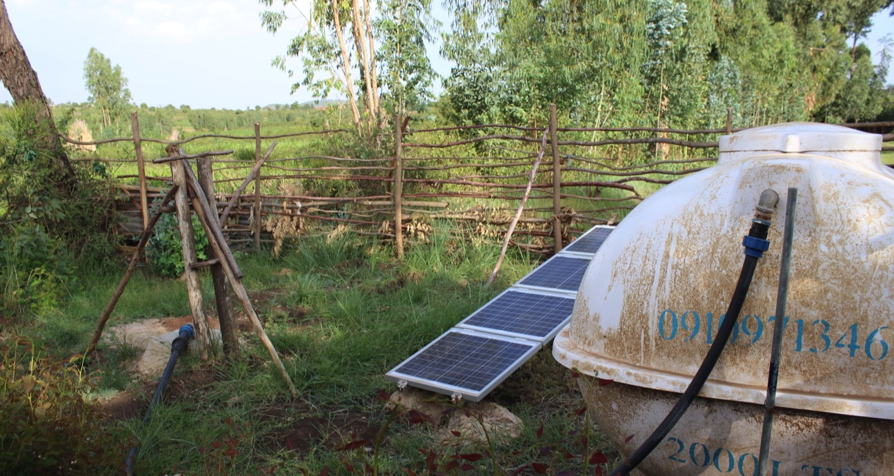
Figure 2. Summary of Beaucage activity in Ethiopia partially funded by the US Embassy. Top: installation of solar lighting in class rooms in East Hararghe. Middle: Electrification of a clinic and installation of a solar well for the school shown at the top. Bottom: Solar well for high-school near Haramaya University and solar street light company showing initial manufacture at DDIT.
In 2014 a $10,000 seed grant was funded to initiate interactions between DDU, MU, and UC. A memorandum of understanding was signed between UC and DDU and faculty exchange between the campuses occurred. A faculty member from DDU and Mekelle visited Cincinnati and Argonne National Laboratory in Chicago. Two faculty from Cincinnati visited DDU and MU and gave seminars on their research. A plan for interaction was developed. The Vice President for International Affairs from UC visited DDU and MU in a later trip. The main outcome from this grant and the MOU was a series of startup business development projects including manufacture of solar street lights at DDU which is still being pursued after several technical improvements over the initial design. 200 street lights have been installed in Somali villages near DDU. We have held annual undergraduate and graduate student exchanges and faculty visits with DDU up until the pandemic curtailed international travel.
In 2018 to 2019 Beaucage was awarded a Fulbright Global Scholar award that included one month in Ethiopia as well as six months at University of Sheffield UK, and one month in South Africa and Lesotho. In Sheffield Beaucage collaborated with a graduate student, Max Yan, six undergraduates and a technical expert, Horace McFarlane, in the development of solar powered soil moisture sensors that can be operated from a cell phone. Using British funding, the Sheffield collaborators traveled to Ethiopia in December 2019 to join Beaucage in successful manufacturing of the device at DDU and AAU as well as field testing of the soil moisture sensors in a test farm in Dire Dawa operated by the Fair Planet NGO and in the AAU Bishoftu drip irrigation test fields near Addis.
Max Yan and Horace McFarlane: Max Yan and Horace McFarlane are collaborators from Sheffield. The have agreed to participate in the development of the drip irrigation control system manufacturing startup in Addis. This is a continuation of the collaboration in the development of the existing field-tested device.
Fair Planet: Fair Planet is an Israeli NGO that targets agricultural development in Ethiopia through providing more productive seed varieties, training farmers, providing agricultural experts to interact with local farmers with extended visits, and by demonstration of improved farming practices such as crop rotation, trellising, fertilization, and drip irrigation. Fair Planet has test farms in Dire Dawa and in the Eastern Hararghe area affiliated with DDU and HU. Fair Planet has agreed to participate in the project by providing test plots for the drip irrigation control systems.
Berhanu Assefa: Dr. Assefa is a Professor of Chemical Engineering at AAU/AAIT who has worked with Beaucage, Yan and McFarlane in the manufacture of soil moisture sensors and the field testing of the sensors. Assefa has links with the drip irrigation test facilities at AAIT where field testing of the drip irrigation control system will be carried out.

Problem Statement:
Agriculture is the backbone of the Ethiopian economy contributing to half of gross domestic product (GDP), 83.9% of exports, and 80% of total employment. [5-9] Ethiopia has 14.5 million hectares of arable land with the potential for three annual harvests. Only about 25% of this land is currently irrigated mostly by flood irrigation which is wasteful of water and energy resources. [10] High-value crops that include fruit, vegetables, and flowers all require additional irrigation. mostly by flood irrigation. Currently, Ethiopia annually imports irrigation equipment worth USD 70 million. The annual market size for the irrigation equipment could reach ten times the size of current imports. [5]
Drip irrigation can significantly reduce irrigation water needs, fertilizer use, and dramatically increase crop yields in some crops such as coffee, papaya, and sorghum. It can also enable new cash crops such as fruits, vegetables and flowers. DI can also lead to the realization of three harvests per year. Modern farming involves close control over the environment provided to growing and producing plants. Agricultural engineering has developed optimized algorithms for the various crops in terms of optimal irrigation, soil moisture content, and fertilization [1-5]. These inputs to growth need to respond to the amount of solar irradiance, temperature, humidity, evaporation, soil type and grading. With rudimentary computing, such as is available in a cell phone app, control over a series of solar powered valves, solar pumps using input from soil moisture, temperature. atmospheric humidity, solar irradiance and soil pH, precise delivery of water and fertilizer can be achieved. Under these conditions dramatic improvement in productivity can be achieved while minimizing the consumption of the main expense of Ethiopian farmers, irrigation. Drip irrigation involves delivery of water and fertilizer to individual plants through small tubes. Monitoring of the delivery of water through soil moisture sensors can improve the maintenance of drip irrigation system blockages.
Control systems manufactured in Europe, Asia, or North America are prohibitively expensive in Ethiopia and are not designed for the unique climate and societal conditions. Foreign purchased irrigation supplies do not have local support infrastructure and are difficult to purchase since most on-line venues are not viable in Ethiopia. Further, we have demonstrated that the main components of these control systems can be manufactured in Ethiopia using available components at a fraction of the cost of the imported devices and well within the buying power of an average Ethiopian farmer. For instance, an imported drip irrigation system currently costs about $14,000 per hectare in Ethiopia. Locally produced cell-phone controlled system manufactured in this project will cost on the order of $2,000 per hectare and reduce irrigation needs at least by a factor of 10 depending on the crop. Local technical support for drip irrigation systems and controls are vital to widespread implementation. The current imported systems have virtually no support in Ethiopia.
Working with experts in the agricultural sector through collaboration with Fair Planet and AAIT and taking advantage of the experience of Stem Synergy in the development of manufacturing in Addis as well as utilizing their 22 STEM sites dispersed across Ethiopia it is proposed to develop a business plan, manufacturing capability and startup capital funding for drip irrigation control systems using this Embassy grant.

Program Goals and Objectives:
The goal of the project is to develop a viable business plan for the manufacture of drip irrigation control systems in Ethiopia and to attract startup funding from Ethiopian, US, and other foreign investors. The control systems will contribute to employment of recent technical graduates of Ethiopian Universities in work that contributes to domestic food security and export through increased crop yields and lowers water and fertilizer usage as well as slows the degradation of irrigated land through salt buildup, and reduction in weeds.
1) 1-6 months: Design of a complete drip irrigation control system that can be run from a cell phone based on our existing soil moisture sensor which currently simultaneously detects soil moisture, temperature, atmospheric humidity, and solar irradiance. We hope to add pH sensing. The new phone app will also control solar powered valves and possibly solar pumps for irrigation. This work will be done in collaboration with the University of Sheffield, AAU/AAIT, and Fair Planet.
2) 4-12 months: The design will be field tested in Dire Dawa on about a 1-hectare field at the Fair Planet research farm preferably with vegetables during the dry season. The timing may be somewhat difficult if the project is initiated in October 2021. The Fair Planet test site is typical of the Somali Region with arid conditions and sandy soil. Parallel to the Fair Planet test site we will test the system in Addis at a test agricultural fields outside of the city. The soil at this test site is rich loam with moderate climate conditions. We previously used both the Fair Planet and the AAIT facilities to test the cell phone-controlled soil moisture sensors which were assembled at AAIT and at DDIT.
3) 6-12 months: Preparation of a business plan to solicit commercial investment based on the field tests and consultation with agricultural experts. We plan to solicit capital from contacts in Addis, the US, and possibly other locations such as Turkey and Israel. We are looking for an initial market value of about $1.5M.
4) 12 month and onward: Further growth of the business after this one-year grant will rely on long term interaction with Fair Planet, AAIT, and the Ethiopian Agricultural Transformation Agency (ATA) and will involve more significant funding.
Assessment of these targets will be carried out through consultation with agronomists and high-level experts at Fair Planet and AAIT at the 3, 6, 9 and 12-month points. These assessments will be included in the project reports.
Improvement in the relationship between the US and Ethiopia: The project will involve direct collaboration between US and Ethiopian technologists, faculty and students. The project will lead to long term relationships. Stem Synergy, and UC will coordinate undergraduate collaboration between UC and AAIT through student exchange. Stem Synergy will enable interaction between Cincinnati students and Ethiopian secondary students studying in their 22 Stem centers in Ethiopia.

Program Activities:

Table 1 shows the time line for the project.

Table 1. Timeline for project.

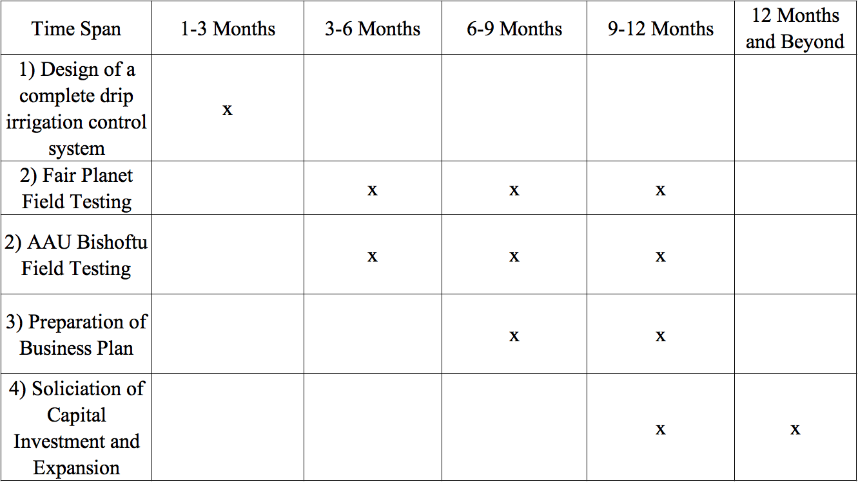
1) 1-6 months: Design of drip irrigation control system.
Two engineers will be recruited from Ethiopian universities with preference to female applicants. This will be overseen by Abiyot Lakew, Manager of STEM Synergy’s Addis Ababa facility. The new staff will work closely with Beaucage and the Sheffield team in the development of a complete drip irrigation control system. The team will consult with staff at Fair Planet and at AAIT. Materials and supplies for assembly of these systems will be purchased include PVC pipes, solenoid valves, controller chips, batteries, solar cells, sensor chips and moisture detectors. We anticipate testing one complete system at each agricultural research facility in Dire Dawa and at AAIT.
Design, development and assembly and initial testing of the devices will take place in the Addis facilities of Stem Synergy. To support the proposed work Stem Synergy International currently has a 1000 m² facility in a walled compound in the suburbs of Addis with a staff of 10 people including four engineers, a business development staff member and secretarial and management staff. The project will support the current supervisor at 35% as well as two PhD engineers from Ethiopian universities with background in development of control devices.
2) 4-12 months: Field test the design in Dire Dawa and in Addis at a test agricultural fields outside of the city.
Field testing will take advantage of existing drip irrigation systems in Dire Dawa/East Hararghe (Fair Planet) and at the AAU agricultural test facilities at Bishoftu near Addis. We previously used these fields to test the cell phone-controlled soil moisture sensors which were assembled at AAIT and at DDIT. The first-year testing will use 1-hectare fields preferably during the dry season on vegetable crops such as lettuce, tomatoes, and cabbage or crops suggested by the agronomists at Fair Planet and the DDIT agricultural research facility. The timing may be somewhat difficult if the project is initiated in October 2021. A control cell-phone app will take account of temperature, humidity, irradiance and soil moisture level to calculate the transpiration of water from the plants. This will be used to calculate the necessary irrigation and will be used to optimize fertilizer addition. We would like to demonstrate detection of flow blockage, and improved growth with the control system over manually controlled drip irrigation and fertilization.
The type of data that will be collected to demonstrate the control systems will be subject to discussion with Fair Planet and the AAIT agricultural station. Initially it is planned to measure maturation time, an estimation of mass yield/hectare, and salt deposition rate compared to flood irrigation and manually controlled drip irrigation. Qualitative observation of the results of over/under watering. Farmer testimonials will be of use in the business development plan.
3) 6-12 months: Development of a business plan.
At the end of the first year we hope to have a marketable control system product, manufacturing protocol, and capital investment to initiate commercial activity in Ethiopia to manufacture drip irrigation control systems for Ethiopian farms. The business plan will incorporate information from the field studies at Fair Planet and at the AAIT experimental farm. The business and accounting personnel at Stem Synergy will make a market assessment based on surveys of farmers conducted in coordination with Fair Planet and the AAIT agricultural station as well as published government statistics. We plan to solicit capital from contacts in Addis, the US, and possibly other locations such as Turkey and Israel.
4) 12 month and onward: Commercialization and capital investment.
The startup funding will result in a viable business plan that will attract capital investment of $1.5M in order to expand manufacture capabilities and staff initially in Addis. It is expected that a team of technicians with be assembled who can service and maintain the Ethiopian made drip irrigation control systems throughout Ethiopia. For this reason, support facilities will be needed in a number of regional centers such as Dire Dawa, Mekelle, Awassa, and Bahir Dar. The project can take advantage of the 22 STEM educational centers of Stem Synergy International for this support network. The Stem Synergy regional footprint will enable rapid implementation of drip irrigation technology and introduction of new cash crops that take advantage of the control drip irrigation systems. We plan to team with Fair Planet, AAIT agricultural station and the Ethiopian Agricultural Transformation Agency (ATA) and other stakeholders in this commercial development.

Program Monitoring and Evaluation Plan:
Assessment of the project targets will be carried out through consultation with agronomists and high-level experts at Fair Planet and AAIT at the 3, 6, 9 and 12-month points. These assessments will be included in the project reports. The progress reports will be used to modify the project approach.

Branding Plan:
Stem Synergy has a strong record in advertising progress in their STEM centers and annual science fair on television and in the printed press. We plan to leverage this developed Ethiopian expertise to market the project and to spread information concerning the US Embassy funding of the effort.

References:
1) Dasberg S, Or Dani, Drip Irrigation Springer-Verlag Berlin Hiedelberg (1999).
2) Goyal MR, Management of Drip/Trickle or Micro Irrigation Apple Academic Press Toronto (2013).
3) Singh A, An Introduction to Drip Irrigation Systems New Delhi Publishers New Delhi (2012).
4) Biswas RK, Drip and Sprinkler Irrigation New India Publishing Agency New Delhi (2015).
5) Mendes DM, Paglietti L, Irrigation market brief, Food and Agriculture Organization of the United Nations International Finance Corporation World Bank Group Rome (2015).
6) Eshete DG, Sinshaw BG, Legese KG, Critical review on improving irrigation water use efficiency: Advances, challenges, and opportunities in the Ethiopia context Water-Energy Nexus 3 143-154 (2020).
7) Ayana M, Eshetu F, Tadele K, Simple and Low-Cost Drip Irrigation System: An alternative approach to raise household farm productivity MoWR/MoARD/USAID/IWMI Workshop 64-71 (2015).
8) Haile GG, Irrigation in Ethiopia, a Review J. Env. Earth Sci. 5 141-147 (2015).
9) Kassa M, Andualem TG, Review of Irrigation Practice in Ethiopia, Lessons from Israel Irrigation & Drainage Sys. Eng. 9 1-6 (2020).
10) https://drts.com/the-market-for-small-scale-irrigation-in-ethiopia/

Attachments:

Resumes:
Yisehak Shata, MEng, PE, ENV SP, Chairman and Board of Directors STEM Synergy International
Tsegaye Legesse MBA/CPA, President and Executive Director STEM Synergy International
Abiyot Lakew, Manager of STEM Synergy’s Addis Ababa facility.
Dr. Berhanu Assefa, Associate Professor of Chemical Engineering, Addis Ababa University
Dr. Gregory Beaucage, Professor University of Cincinnati

Letters:

Dr. Shoshan Haran, Founder and President Fair Planet
Dr. Berhanu Assefa, Associate Professor of Chemical Engineering, Addis Ababa University
Maxwell Yan, Graduate Student, Department of Chemical Engineering, University of Sheffield UK
Horace McFarlane, Technical Specialist, University of Sheffield, UK
Dr. Belete Bantero, Senior Transformation Agenda Specialist II, Ethiopian Agricultural Transformation Agency

Unique Entity Identifier and System for Award Management (SAM.gov):

Unique Identifier Number from Dun & Bradstreet (DUNS number):

NCAGE/CAGE code :

