Structural and surface studies of heterogeneous catalysts using small-angle x-ray (SAXS) and neutron (SANS) scattering.

G. Beaucage^{1*}, P. R. Jemian², T. P. Thiyagarajan³

1 Chemical and Materials Engineering Department University of Cincinnati, Cincinnati OH 45221-0012
2 UNICAT, Advanced Photon Source (APS), Argonne National Laboratory, Argonne IL
3 Intense Pulse Neutron Source (IPNS) Argonne National Laboratory Argonne IL

Small-angle scattering of x-rays (SAXS) (and neutrons SANS) describe structure from the molecular size-scales of x-ray diffraction to the colloidal-scale and can overlap with light scattering using ultra small-angle instruments such as the UNICAT Bonse-Hart facility at APS. Both ordered structures such as zeolites and disordered structures such as ceramic aggregates and gold nano-particles have been studied. The SAXS structural description for heterogeneous catalysts generally involves an observed intensity in inverse space (q- scattering vector) and a parallel, statistical description in real space, mean pore size, pore-spacing, particle size, particle size distribution, aggregate size, fractal dimension, such as the mean surface area and the like. Many of these features can also be described using microscopy and gas absorption techniques. One advantage of SAXS is that statistical rather than local values are generally obtained. In addition to statistical measures of catalyst structure, SAXS offers access to an extremely wide range of sample environments from atmospheric conditions to high pressure and temperature and corrosive gas environments, 2D pinhole SAXS/WAXS instruments (DNDCAT, BIOCAT, BESSRC and other CAT''s at the Advanced Photon Source) offer rapid measurement time (10 ms) for the potential of in situ studies of catalysts during reaction and activation. Finally, SAXS is a non-destructive technique with the possibility of multiple detectors for simultaneous wide angle scattering (WAXS), spectroscopy or other analysis simultaneous with SAXS measurements. Uniquely, synchrotron SAXS can be conducted on a wide range of catalyst concentrations form the extremely dilute conditions of an aerosol spray (parts per million), to measurements on bulk powder. Further, the SAXS/SANS measurement can be conducted in transmission or reflection mode (GISAXS), although scattering in reflection is often difficult to interpret using conventional scattering theory. SAXS/WAXS (and SANS/NPD) studies offer a unique window for the understanding of structural effects on the activity and activation of heterogeneous catalysts. Contrast variation can be achieved in SAXS using several wavelengths near the absorption edge (ASAXS) or using isotope substitution in SANS.

*beaucag@uc.edu This review is partly based on a presentation given at and discussions resulting from Argonne Workshop on Catalysis Argonne National Laboratory September 2005.
Introduction:
The field of heterogeneous catalysis has made major advances over the past 25 years in our understanding of molecular-scale and crystallographic structure and the importance of these molecular-scale structural features in controlling chemical reactions [1,2]. Recently our structural understanding of these systems has broadened towards possible implications of nanometer-scale and colloidal-scale structure on heterogeneous reactions. A salient example is supported catalysts, particularly gold nano-particles supported on high surface-area oxide supports such as alumina supports [3-5]. Also of relevance to nanometer and colloidal scale structure are zeolites and complex mixed oxide catalysts [6]. Our general understanding of nanometer to colloidal-structural effects in heterogeneous catalysis is weak. The application of techniques, such as small-angle scattering, are expected to open new windows for design of heterogeneous catalysts in the next decade.
Molecular-scale structure has been elucidated largely through the application of spectroscopy, for example XAS, EXAFS and XANES, and x-ray powder diffraction (XPD) due to the quantized nature of molecular structure [7]. Analysis of nanometer- and colloidal-scale structure requires tools designed for larger-scale, generally non-quantized structures. The meaning of structure on the nanometer- to colloidal-scale differs from that on a molecular scale. On larger size-scales we deal with features that display statistical distributions. Crystallographic indexing, for example, is of only vague use on the colloidal scale where differences between crystallographic systems can not be determined since generally only one or a few reflections are observed even in "perfectly" ordered zeolites and colloidal crystals. On the nanometer- to colloidal-scale, thermodynamic laws that define crystallographic structure on the atomic scale, begin to break down and this, combined with generally polydisperse structural size, leads to a wide distribution of size and spacing when compared with the atomic scale.
Traditionally, the catalyst community turns to non-statistical methods for structural characterization on the nanometer to colloidal scale such as transmission and scanning electron microscopy and atomic force microscopy [1]. These methods, while increasingly powerful in terms of resolution, are extremely limited in observable size range and in terms of statistical description. The natural tools to describe structural dispersion, size, as well as the complex disorderd, 3D features observed on the nanometer to colloidal size-scales are small-angle scattering of x-rays and neutrons. This review introduces recent advances and potential applications for small-angle x-ray (SAXS) and neutron (SANS) scattering in heterogeneous catalysis. Both laboratory source x-ray cameras, as well as synchrotron and neutron sources are discussed. Synchrotron sources are indispensable for in situ studies as well as for variable wavelength studies (anomalous SAXS), while neutron scattering can offer enhanced contrast, superior sample penetration depth and a wider range of scattering vector than is available from x-rays. This review will give a summary of SAXS and SANS instrumentation facilities in the US (and some in Europe for comparison), laboratory-source instrumentation options, list the quantifiable features for heterogeneous catalysts, describe SAXS analysis options, as well as providing a sampling of software which is available for SAXS/SANS data reduction.

Outline of Review:

-Introduction
-Instrumentation
Overview, Small angle x-ray (and neutron) scattering
Laboratory Source Instruments
Synchrotron Instruments:
USAXS Instruments
Pinhole Instruments
WAXS/SAXS Instruments
ASAXS Facilities
GISAXS Facilities
Neutron Scattering (SANS) Instruments
-Scattering analysis options
Construction of a Scattering Curve and the Unified Approach
Specific Surface Area and Sauter Mean Diameter
Particle Size Distributions
Correlation Analysis
Analysis/Reduction of GISAXS Data
Analysis/Reduction of ASAXS Data
Analysis/Reduction of SANS Data
-Suggested/Sample of Software
-Summary

Instrumentation:
Overview, Small angle x-ray (and neutron) scattering: Scattering of x-rays was developed during the 1930's as an outgrowth of early studies in diffraction. The field rapidly advanced during the 1950's primarily due to contributions from Andre Guinier (and Gerard Fournet) in France [8] and G. Porod [9] in Austria. The technique has suffered from low flux since the earliest measurements since detection of scattering at angles below a few degrees requires well collimated beams on the order of 20 micron diameter usually using slits leading to loss of most of the intensity from a typical x-ray, lab generator. Further, SAXS requires a monochromatic source leading to further loss of the initial flux.
Scattering models for data interpretationj generally assume a pinhole geometry experiment with a parallel, monochromatic, pencil beam. In the pinhole SAXS measurement, a collimated monochromatic beam (typically 1.5 Å or about 10 keV) of about 50 micron diameter is incident normal to a thin sample's surface. The optimal sample thickness (or path length through the solid fraction for powders) is 1/μ, where μ is the linear absorption coefficient. For a ceramic oxide this is typically 0.1 mm, for a metal it is somewhat lower and for an organic or polymer typically 2 mm. (For neutrons this thickness can be 5 mm to 5 cm for a ceramic or metal offering a major advantage over X-rays.) The beam passes through the sample and to a beam stop or transmission detector. Since air and windows scatter significantly in the small-angle regime and because the already weak beam is further diminished on absorption by air, it is preferable to run SAXS measurements in vacuum with a minimum number of windows where possible. For lab measurements, samples are often sealed in glass capillaries if they are liquid or otherwise sensitive to vacuum conditions. Measurement of a 1D or 2D scattering pattern is typically conducted a moderate distance from the sample, typically 1 to 2 meters. Measurement of the transmitted beam for scaling of the background is vital to data correction. The data is generally reduced using the following function,

$I_{\text{corrected}}\left(q\right)=\frac{K_{\text{instrument}}\left[I_{\text{measured}}{\left(q\right)}/T−I_{\text{background}}\left(q\right)\right]}{t_{\text{sample}}}$ (1)

Where the background (cell/solvent/camera) is subtracted from the sample data after dividing by the transmission ratio, T = I(0)_{sample}/I(0)_{background}. For a sample of optimum thickness T = 1/e or about 0.27. The corrected data is divided by the sample thickness (path through solid sample) and multiplied by an instrumental constant to obtain absolute intensity in units of 1/thickness. Multiplication by the molar volume yields contrast cross section for the material.
q is the scattering vector generally in units of Å⁻¹ (more rarely expressed as nm⁻¹). q is calculated from,

$q=\frac{4π}{λ}\text{sin}\left(θ2\right)=\frac{2π}{d}$ (2)

where θ is the scattering angle (note that 2θ_{diffraction} = θ_{SAXS}). Equaton (2) can be expressed in terms of the crystallographic d-spacing (last equality in equation (2)).
The scattered intensity as a function of q can be though of as being proportional to the number density of domains of a size d, N, the square of the number of electrons (or other contrast elements), n_{e}², since scattering involves binary interference events, and a contrast factor reflecting the scattering from a single electron (or single contrast element) combined with a term reflecting camera geometry, K_{camera}. The number of electrons, n_{e}, is proportional to the electron density, ρ_{e}, times the volume of a domain of size d, V ~ d³, so,

$I\left(q\right)=K_{\text{camera}}{\text{Nn}}_{e}^{2}\text{\sim }{Nρ}_{e}^{2}d^{6}$ (3)

For example, for scattering from particulate surfaces, the number of domains of size d is given by N ~ N_{p}S/d² where S is the surface area of a particle and N_{p} is the number of particles, so, $I\left(q\right)\text{\sim }N_{p}{Sρ}_{e}^{2}d^{4}$ and using (2),

$I\left(q\right)\text{\sim }N_{p}{Sρ}_{e}^{2}q^{−4}$ Surface Scattering (3').

Scattering data is generally presented as a log-log plot of I versus q to emphasize power-law relationships between structure (amount and contrast at a measured q) versus size (q). Generally, many scattering laws take the form of power-law or exponential decays, (3') for instance, which are naturally amenable to a log-log representation.

Laboratory Source Instruments: The design of laboratory source instrumentation has focused on increasing the flux delivered to the sample, which is generally insufficient for useful measurements at small angles with the necessary narrow collimation and monochromatization. Some advances were made in the 1940's in camera design that allowed the use of a larger fraction of the generated X-rays (Kratky camera, Figure 1a) [8,9]), but, for the most part, there are distinct advantages to synchrotron radiation for SAXS measurements given that well-collimated, monochromatic, high-flux beams are common at many synchrotron beamlines. Generally, a synchrotron source is a requirement for in situ studies, studies of low concentration samples and studies that require control over the incident wavelength (ASAXS).
Figure 1 shows schematics of three typical lab source SAXS cameras suitable for the study of heterogeneous catalyst powder: a) the Kratky camera, b) the pinhole camera and c) the focusing optics camera. Typically, a laboratory source for SAXS requires a rotating anode generator of at least 12 kW rated power often using a fine filament that can be tuned to act as an effective pinhole optics component. Depending on the camera's angle of view of the filaments shadow on the rotating anode, the source can be a line of the length of the filament (about 1 cm) and the width of the footprint (0.2 mm), or a point (filament footprint diameter, typically 0.2 mm). In the Kratky camera, Figure 1a), the line source beam is used to increase the incident flux by a factor of about L/D ~ 500 where L is the beam width (~10 mm) and D is the beam height (~0.02 mm). The asymmetric beam is collimated only normal to the line using two blocks that can be adjusted down to a vertical gap of about 10 micron. Generally, a graphite monochromater is used near the x-ray tube tower. The flight path and sample are under roughing vacuum and the sample/optics chamber ends in a beryllium window with a 1-d detector (Braun proportional counter wire-detector for instance). The beam stop is a block of lead that can be adjusted in vertical position as well as rotated out of the beam. The transmitted beam can be measured by insertion of a filter and removal of the beam stop. Generally, the transmission is measured using a commercial moving slit apparatus in addition to the filter in separate measurements from the data collection run. For the most part, Kratky measurements are archaic for several reasons, although they offer high flux at low cost (currently about $20,000 for the camera and detector and about $100,000 for the generator). A Kratky camera can potentially be modified for diffraction and has even been modified for reflectivity measurements [10]. The proportional wire detector can be adjusted to accept a narrow window of wavelength making a monochromator less of a necessity. In such a setup a nickel filter would be used to remove the copper K-β radiation and the detector can further narrow the measured K-α wavelength (such as in the Bruker pinhole SAXS instrument).

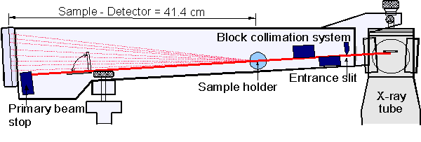
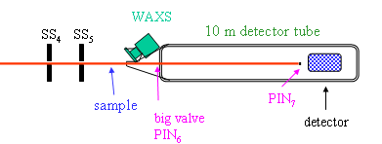
Figure 1. Laboratory Source SAXS Cameras. a) Kratky From http:// www.uni-bayreuth.de/ departments/ pci/ SAXS.html. The beam is a line source into the page and the detector is a linear detector normal to this sheet beam at the end of the evacuated chamber, b) Pinhole camera design (ID02 ESRF France), c) Focusing optics camera. The first arc from the source is a curved mirror, the second is a bent crystal monochromator that is orthogonal (out-of-plane) to the first mirror though it is shown in-plane in the schematic.

Kratky data is "smeared" meaning that the measured intensity at a given angle or value of q, I(q)_{observed}, along a vertical line into the page in Figure 1a, can result from any source point along the beam footprint on the sample (into the paper in Figure 1a). Each different point along the beam footprint on the sample results in a different value of scattering angle and q for a given detector channel normal to the line beam. These different values of q are summed on a single channel leading to a smearing of the scattering pattern. If the exact shape of the incident beam is know it is possible to "desmear" the resulting pattern either iteratively (Lake method [11]) or by brute force (Schmidt method [12]). Figure 2 shows a typical smeared and desmeared scattering pattern from an ultra-high molecular weight polyethylene sample using the Lake method showing that smearing primarily effects data at lower -q. but has a strong effect on the scaling of I versus q across all of the measured q. Notice that the desmearing operation leads to an increase in the error bars. Generally, laboratory source scattering data has insufficient scattered intensity, signal-to-noise, to be routinely desmeared with confidence while synchrotron sources have such an excess of flux (~10,000 times an X-ray rotating anode source) that the flux limitations that made the Kratky approach reasonable for lab sources do not exist. Further, an exact description of the scattering source seems to be inaccurate for Kratky optics since there is no good method to determine the uniformity of the beam width across the irradiated area.
Non-uniformity of a sample across a 1 cm beam length or alignment problems when using a capillary effects the accuracy of desmearing and the validity of the assumption of a 1-d scattering volume. Further, the Kartky camera is unable to resolve 2d features (some spurious) from data because it uses a 1d detector. Kratky cameras are also unable to effectively measure nano-structural orientation (often a prominent feature in the small-angle regime). It is a general observation that pinhole cameras are more reliable and robust compared to Kratky geometry cameras. Generally, the Kratky camera has the advantage of higher signal and a much wider q-range compared to pinhole cameras. Kratky cameras are often used in biology where liquid samples are examined with weak signals and isotropic patterns. For ceramic or metal powders, pinhole cameras are more useful.

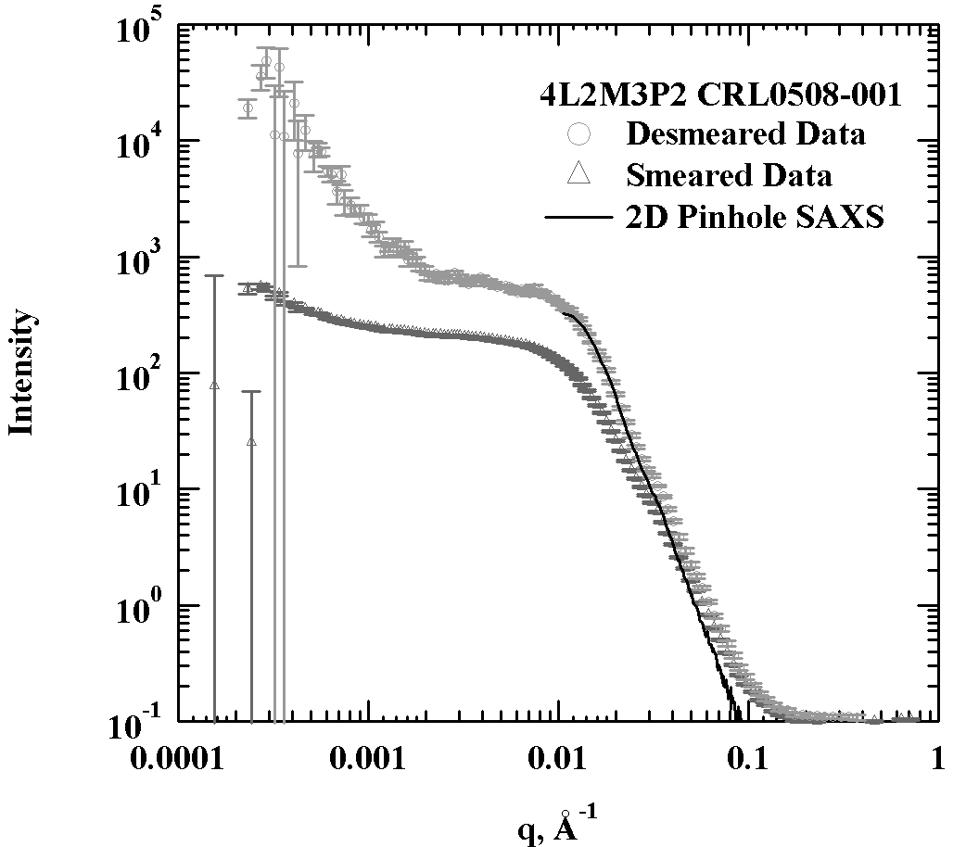
Figure 2. Smeared SAXS data, I versus q, after background subtraction, with desmeared data showing the effect of desmearing on the data. Superimposed is a SAXS pattern from the 2D pinhole SAXS prior to the detector failure. The data shown is from the UNICAT (APS) Bonse-Hart camera though the features of smearing and desmearing are characteristic of Kratky or Bonse-Hart cameras.

The second two lab source cameras in Figure 1 use a point source or pencil beam. The highest flux camera is the focusing optics 2D camera. This camera offers higher effective signal than the Kratky camera due to the bent mirror optics and 2D detection, it offers the ability to observe orientation of a pinhole camera, however, the normal range in size resolution is 1.5 orders typically from 1 nm to approximately 50 nm. Further, the focusing optics camera requires more maintenance compared to Kratky and pinhole cameras. The sample to detector distance is fixed with focusing optics so the camera is not extremely flexible and can not be reasonably used in a SAXS/WAXS arrangement. The focusing camera does not require desmearing.
The most flexible camera in Figure 1 is the pinhole camera since the detector can be moved to any position from close to the sample for diffraction, to up to 5 m or more from the sample for extremely low angle measurements assuming an evacuated or helium filled flight path. The lowest angle is limited by collimation and typically scattering vectors on the order of 0.002 Å⁻¹ (0.02°) are the lowest that can be achieved using a lab source and a pinhole camera. (A Bonse-Hart camera, discussed below, can measure scattering at 0.0001 Å⁻¹ or about 0.001°, 20 mrad). Parallel optics pinhole cameras (3 pinhole arrangement) can be easily modified for SAXS/WAXS measurements, Fig. 1b.

Typical Synchrotron Instrumentation: At synchrotron facilities the focus of instrument improvements/limitations changes from improvement in flux to improvement in:

1) Range of scattering vector, q_{minimum}.
2) Measurement and data transfer time for in situ studies using 2D and multiple detectors.
3) Simplicity of on the fly measurement using different wavelengths for ASAXS.

The first issue has been widely considered at synchrotron facilities in the US and Europe as well as in Asia. The SAXS camera with the widest q-range was developed by Bonse and Hart in the 1950's in experiments on x-ray mirrors and channel cut crystals (Hart is now director of Brookhaven National Lab's NSLS facility) [13]. The camera is often referred to as an ultra-small-angle scattering camera (USAXS) (although the term has recently expanded to include highly collimated pinhole cameras such as the Dupont instrument at DNDCAT, APS). In a Bonse-Hart camera two matched crystals are used. The first crystal is called the monochromator and it provides a narrow wavelength distribution beam to the sample with moderate collimation. Often a multiple bounce crystal is used in order to narrow the rocking curve for the two matched crystals. This can be a channel cut crystal or paired crystals oriented with automated goniometers and positioning stages. The second crystal must be a duplicate of the first and is rocked to sample the divergence angle of the first crystal after the beam passes through the sample. The detector is a pin diode or other single channel detector with electronics that allow for calibrated scanning of up to 11 orders of intensity. The rocking curve scans through the "main beam" (0° divergence) allowing for a primary measurement of absolute intensity (absolute cross section) for each sample. Since the Bonse-Hart camera is a step scanning camera the measurement typically requires about 10 to 30 minutes on a synchrotron beamline most of which is used for motor motion.

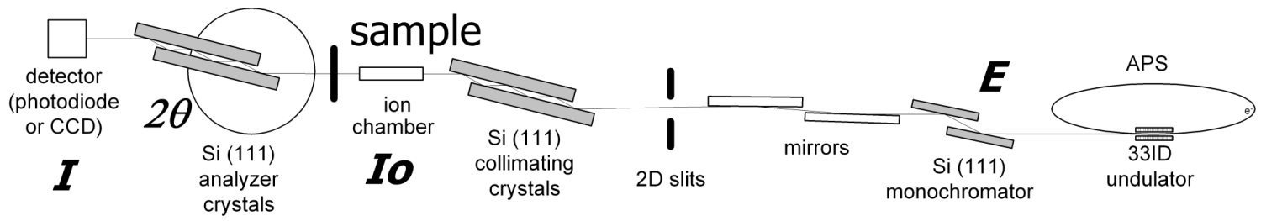
33 ID UNICAT
Figure 3. Bonse-Hart USAXS camera at UNICAT, APS [13].

Item 2 above refers to pinhole and focusing optics cameras with 2d detectors. Pinhole cameras can be modified at synchrotron facilities to reduce q_{minimum} through upstream beam collimation, extension of evacuated flight paths after the sample and through detector and beam stop improvements. Several pinhole cameras with q_{minimum} < 0.001 Å⁻¹ exist in the US and Europe, particularly, DNDCAT APS, BESERC CAT APS, ID02 ESRF. Several other "ultra" SAXS cameras are planned at synchrotron facilities around the world. Item 2 is for the most part beyond the scope of this review since it mainly involves improvements in detector electrons and physics. Generally 2D CCD detectors with 20 millisecond resolution are common and micro second detectors are now available at some specialized facilities such as at BESERC CAT at APS and at ESRF. Through use of special mixing cells and flow through studies it is possible to improve time resolutions to the micro-second scale using detectors with accusation speeds many orders of magnitude slower than this [Beaucage Flame studies].
Generally issue (3) is a design issue associated with the upstream components of a synchrotron beamline so can not be effectively considered in this reveiw except to state that the requirement is for measurement on the identical sample position with no chemical change (in as short a time as possible) using as many wavelengths of as wide a range as possible. It is desirable to find the functionality of I(q) versus wavelength on the same irradiated volume in a short period of time (seconds).
WAXS/SAXS Instruments: A simple modification of a pinhole SAXS camera is modification of the post sample flight path to include a 2D or 1D diffraction detector from 1 to 10 cm from the sample. Typically, half or a quarter of the SAXS pattern is sacrificed for the WAXS (wide angle x-ray scattering) detector. synchronization of the WAXS and SAXS camera exposures has been implemented on several synchrotron beam lines such as DND at APS and ID02 at ESRF [14].
ASAXS Facilities: ASAXS instrumentation involves essentially up-stream modification of one of the SAXS cameras such as Bonse-Hart or pinhole cameras, Figure 4. A simplified pinhole-camera geometry is shown in Figure 4. ASAXS cameras takes advantage of the quantized transition of scattering cross section for x-rays in the vicinity of the absorption edges such as the K orbital edge. Measurement of the scattering above and below the absorption edge will allow subtraction of the two scattering patterns to yield scattering associated with only one element in the sample. The available energies typical from a synchrotron insertion device range from 4.5 to 35 keV allowing for observation of K edges for elements with atomic numbers between 21 (Sc) and 55 (Cs) [ref for fig 4]. Other absorption edges (L₃) can be used for higher atomic number elements such as platinum and gold. ASAXS is then a useful technique for structural investigation of transition metals on the nano- to colloidal-scales as well as transition metal organic complexes and mixed oxide and supported metal systems. A difficulty of ASAXS measurements is the inherent fluorescence of elements just below the absorption edge energy. This fluorescence requires a highly monochromatic incident beam which is a similar criterion needed for XANES and EXAFS making dual use or parallel use instruments a possibility. [15]
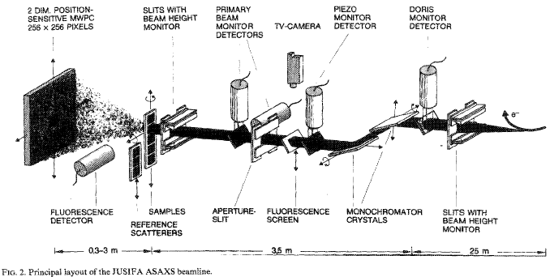
Figure 4. ASAXS camera HASYLab [16].

GISAXS Facilities: For a film, wafer or liquid surface sample the scattering intensity from surface species can be enhanced through the use of an incident beam at low or grazing incidence, typically 0.2° for a silicon substrate for instance. If the intensity is measured at a specular angle using a single channel detector (equal incident and exit angles) the intensity as a function of incident angle (or q calculated using this angle) is called the reflectivity curve. For a smooth surface this reflectivity curve displays a plateau at low angle followed by a decay beyond the critical edge that typically follows a q⁻⁴ power-law with superimposed oscillations associated with the presence of a surface film whose thickness and structural features normal to the surface give rise to features in the reflectivity curve. Despite the simplicity of the reflectivity measurement, analysis is plagued by a variety of unknown parameters such as surface roughness, planarity and composition fluctuations in the sample plane. In addition to the reflectivity curve it has been widely noted that off-specular intensity is a dominant feature in most samples, intensity at values of the exiting angle that do not match the incident angle. Figure 5, for example, shows a GISAXS pattern from a bio-membrane with discrete features associated with membrane structure. Generally such features are diffuse and different regimes of scattering significantly overlap.

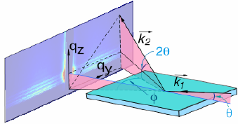
Figure 5. GISAXS Geometry from BIOCAT APS [17]. The 2D pattern shown is from grazing incidence SAXS from a biological membrane that displays both in plane and plane normal structure.

If the incident angle is below the critical edge, an evanescent beam will propagate along the surface of the sample. At higher tilt angles, the majority of the incident beam penetrates the sample. Since it is possible for the incident beam to internally reflect from surface films or concentration/composition gradients at the surface, there is some question as to the precise value of q in a GSAXS measurement since several sources are possible for a given scattered photon. The GISAXS pattern is, in the best conditions, a superposition of at least three sources of x-ray intensity: scattering, reflection and transmission. These features have made quantitative analysis of GISAXS patterns from samples other than the most ideal and model systems difficult. Nonetheless, GISAXS offers potential to contribute to our understanding of heterogeneous catalysis especially when samples prepared for spectroscopic techniques that involve reflection geometry are to be examined for nanometer to colloidal scale structure.

Typical Neutron Instrumentation: SANS facilites are generally similar to pinhole SAXS facilities except that the beam is typically 1 cm in diameter (rather than < 0.1 mm for x-rays) and the flight path is one to two orders of magnitude larger. Detection time for neutrons is typically on the order of 0.5 to 2 hours making in situ time resolved studies difficult. The advantages of neutrons are that the contrast can be varied through isotope substitution, the beam can penetrate great depths in metals and ceramics and magnetic fields can be used for contrast. Bonse-Hart neutron cameras can access q_{minimum}'s of 0.00001 Å⁻¹ and lower (up to 10 or 100 micron size-scales). SANS is often used for aqueous and organic solvent systems using heavy water or other inexpensive deuterated solvent systems for contrast enhancement. Figure 3 shows a comparison of micelle scattering from x-ray, neutron and light scattering. Generally, neutron scattering is an underutilized technique for characterization of heterogeneous catalysis systems.

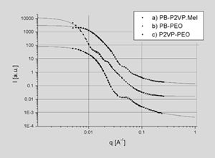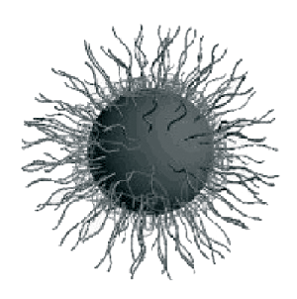
(Thiyaga, I can get Light scattering if this is needed).
Figure 5. Comparison of micelle scattering for SANS, SAXS and light scattering [18].

Scattering Analysis:
Small-angle x-ray and neutron scattering yields average structural information. The shape of the scattering curve can be classified into four categories depending on the polydispersity in size of the structures and the concentration of structures (correlations). Figure 6 shows 4 types of scattering pattern associated with four conditions. 1) For monodisperse spheres sharp oscillations are observed associated with the dominant structural size 2R. 2) With increase in asymmetry or polydispersity in this dominant size the curve qualitatively looses sharp peaks and the high-q scattering increases in magnitude for a given average size. 3) Polydisperse particles can correlate which leads to a correlation peak associated with this new dominant size associated with packing of asymmetric or polydisperse particles. 4) Monodisperse particles with strong correlations lead to a diffraction pattern (not shown) but a curve showing the effect on the high-q part of the scattering pattern with reduction in particle polydispersity in size with fixed correlations is shown. (For a crystalline sample the scattering appears flat with sharp peaks associated with the dominant diffraction planes.) For heterogeneous catalysts we are often interested in disordered/dilute polydisperse particulates that may display aggregation (not shown in figure 6). For such materials, type "2" in Figure 6, generic scattering laws can describe the observed scattering.

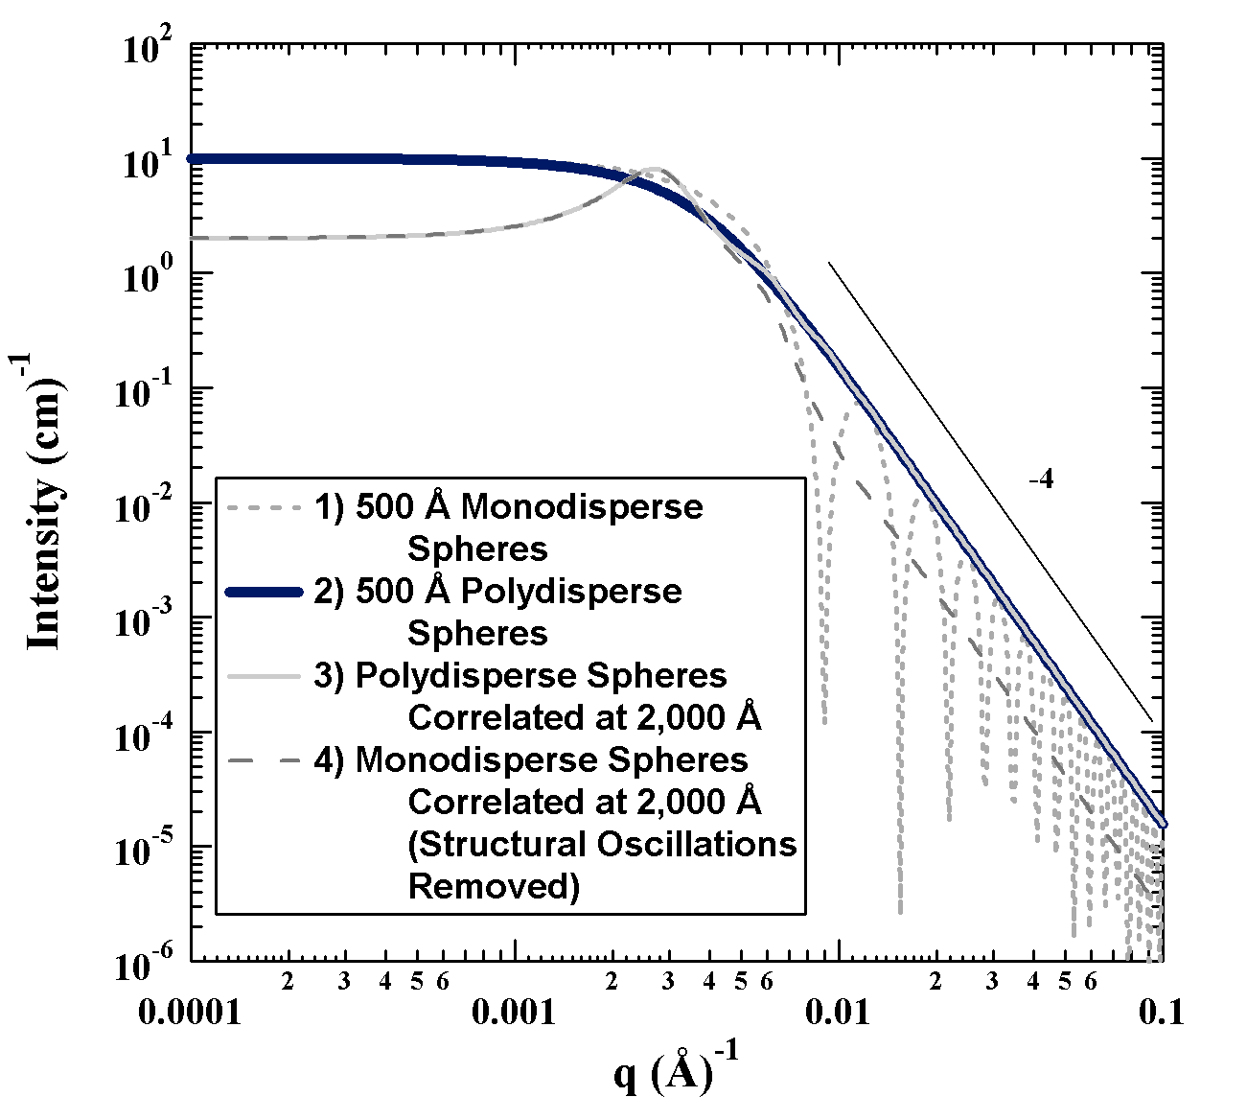
Figure 6. Categories of small-angle scattering patterns, a) dilute polydisperse, asymmetric particles with mean particle size of about 500 Å, b) same particles as "a" correlated at 2,000 Å (concentrated), c) dilute monodisperse spheres of 500 Å radius, c) concentrated monodisperse spheres correlated at 2,000 Å.

Generic Scattering Law to Construction a Scattering Curve: Figure 7 shows a typical scattering pattern from an aggregate structure as calculated using the unified scattering function [refs to unif]. The diagram to the right shows that the aggregate is composed of a hierarchical structure made-up of molecular-scale crystals (bottom), nanometer-scale particles (bottom and middle) that are constructed into aggregates (middle) on a ten nanometer scale and weakly bonded agglomerates of aggregates (top) on a micron scale which might make-up a powder structure. The scattering curve is plotted on a log-log scale to emphasize power-law scattering, eqn. (3').
To construct a scattering pattern we consider first the nano-scale primary particles which display a knee-like regime at high-q (Guinier Scattering in Fig. 7). Guinier's Law,
$I\left(q\right)=G\text{exp}\left(\frac{−q^{2}R_{g}^{2}}{3}\right)$ (4)
describes this knee-shaped decay in terms of a characteristic size, the radius of gyration, R_{g}. The squared radius of gyration reflects the ratio of the 8'th moment of size to the 6'th moment. For a polydisperse sample the radius of gyration is a number of limited relevance since it reflects only the largest components of the distribution.

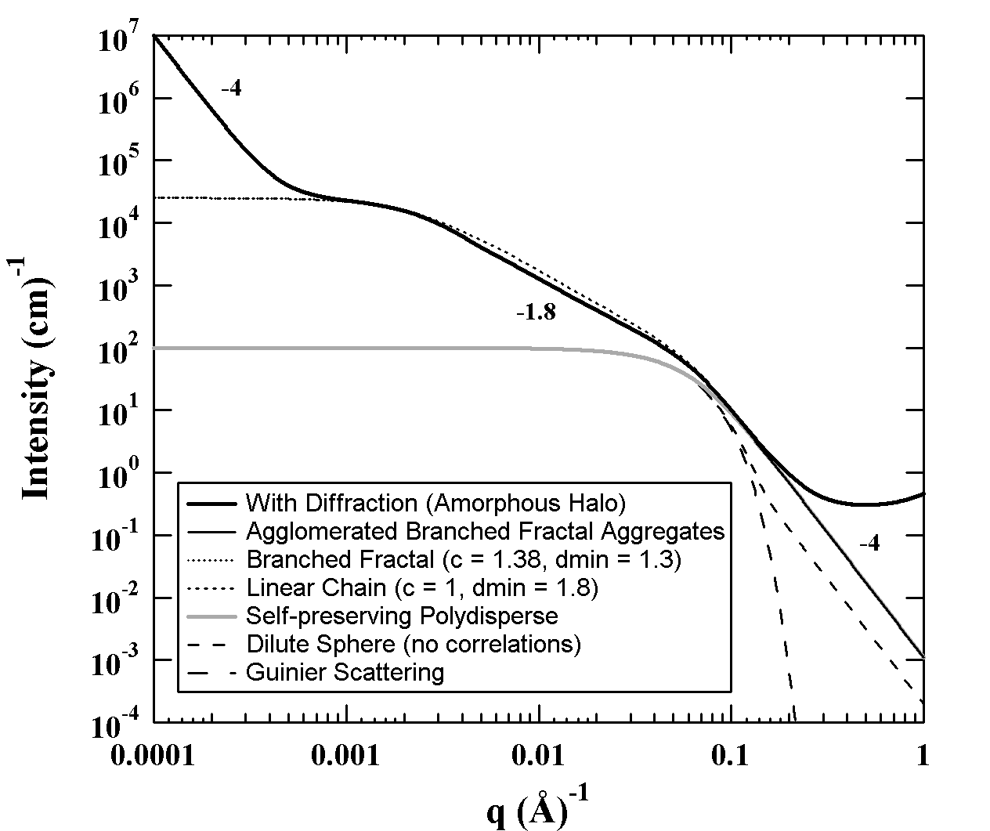

Figure 7. a) Log-log plot of scattering for aggregate structure. b) Structure corresponding to the scattering shown in "a".

Guinier's Law, Equation (4), reflects a particle with no surface [8,19-23]. Porod obtained an expression that describes scattering from the surface of particles [9],

$I\left(q\right)=2π\text{NS}ρ_{e}^{2}q^{−4}=2πN\left(\frac{S}{V}\right)\frac{n_{e}^{2}}{V}q^{−4}={\text{Bq}}^{−4}$ (5)

where N is the number density of particles, S is the surface area of a particle, V is the volume of a particle, ρ_{e} is the electron density difference between a particle and the matrix in which it is imbibed, n_{e} is the number of excess electrons in a particle. A sphere is a particle with the minimum surface area for a given average size. In Figure 5, the lower dashed line (dilute sphere with no correlation) at highest q reflects Porod's Law for particles with the surface area of a sphere. For polydisperse or asymmetric particles the surface area, B, relative to G and R_{g} can only be larger than that for a sphere. The solid line in Figure 5 (solid grey line) at highest q reflects polydisperse primary particles [21-23].
At lower q, 0.01-0.001 Å⁻¹, a weaker power-law is seen. For power-law scattering with a slope less than 3 but greater than 1 the scaling reflects a low-dimension object, and the two knees at the start (low-q) and end (high-q) of this weak power-law regime reflect the two dominant sizes of the low dimension object, for example: the length and diameter of a rod, the diameter and thickness of a disk and the aggregate and primary particle size for a mass fractal aggregate. Mass fractal aggregates follow a structural scaling law between these size limits,

$\frac{M}{M_{0}}=α{\left(\frac{R}{R_{0}}\right)}^{d_{f}}$ (6)

where, M and R are the mass and size of the aggregate, M₀ and R₀ are the mass and size of a primary particle, α is a constant on the order of 1 called the lacunarity, and d_{f} is the mass fractal dimension that ranges from 1 to 3. For example, for a rod d_{f} is 1, for a disk d_{f} is 2. The scattering law that applies for a mass-fractal aggregate is,

$I\left(q\right)=B_{f}q^{−d_{f}}$ (7)

where for a linear aggregate B_{f} is given by [24],

$B_{f}=\frac{G_{2}d_{f}}{R_{g,2}^{d_{f}}}Γ\left(\frac{d_{f}}{2}\right)$ (8)

and for a branched aggregate by [25],

$B_{f}=\frac{G_{2}d_{\text{min}}}{R_{g,2}^{d_{f}}}Γ\left(\frac{d_{f}}{2}\right)$ (9).

where equation (8) is a special case of equation (9) when d_{min} = d_{f}, and G₂ is the Guinier prefactor (equation 4) for the aggregates (lowest q), R_{g,2} is the radius of gyration for the aggregates, d_{min} is the minimum dimension for the aggregate described below and d_{f} is the mass fractal dimension from equation (6). (Γ( ) is the gamma function.)
A linear aggregate consists of an aggregate with no branch points such as a linear polymer chain. A linear aggregate can be described with a single mass-scaling dimension. A branched aggregate requires two dimensions for a full description. The minimum dimension reflects the mass fractal dimension for a conducting path through the structure in the absence of branching. The mass fractal dimension retains the definition of equation (7). The ratio of the mass fractal dimension to the minimum dimension is called the connectivity dimension and is a measure of the linearity of the structure since d_{min} = d_{f} for a linear structure,

c = d_{f}/d_{min} (10)

The maximum value for c is d_{f} and an object where c is d_{f} and d_{min} is one is called a regular object. This is true of a rod, disk and sphere for example. A supposition of fractal theory is that a unique regular object exists for any mass-fractal dimension between 1 and 3 although regular objects other than rods, disks and spheres are difficult to visualize (since they natively exist in non-integer dimensions). The fraction of primary particles present as branches in an aggregate is given by,

$φ_{\text{br}}=1−z^{1c−1}$ (11)

Figure 7 shows the effect of branching on the SAXS pattern. In the mass-fractal regime, the top dashed curve is for linear aggregates while the lower solid curve is for branched aggregates. Branching leads to a knee-like feature in the mass-fractal regime near the aggregate Guinier regime at low q.
At lowest-q, in Figure 6, a second Porod regime appears reflecting the surface of large scale structures (low-q) which are weakly bound clusters of aggregates in this case, called agglomerates. Further, at highest-q the curve plateaus or tails up due to crystallographic or liquid-like diffraction associated with the beginning of the wide angle regime.
Aggregate scattering is described by the aggregate size, R, the primary particle size, R₀, the degree of aggregation z, the minimum (conducting) path length, p, the fractal dimension, d_{f}, and minimum dimension, d_{min}. These are shown for three schematic 2d aggregates in Figure 8. The first aggregate is linear so c = 1 and d_{min} = d_{f}. The second and third aggregates in Fig. 8 show higher branch fractions, φ_{br}. The schematic is misleading because the primary particles and aggregates actually display polydispersity in size and branch content, yet the schematic serves as a model for quantification of aggregate structure.

a b c
Figure 8. Several schematic aggregates in 2d space (1<= d_{f} <=2). a) R/R₀ = 5.25, z = 6, p = 6, d_{f} = ln6/ln5.25 = 1.08 = d_{min}, c =1, φ_{br} =0; b) R/R₀ = 5.25, z = 10, p = 6, d_{f} = ln10/ln5.25 = 1.39, d_{min} = ln6/ln5.25 = 1.08, c = 1.29, φ_{br} =0.40; c) R/R₀ = 5.25, z = 13, p = 6, d_{f} = ln13/ln5.25 = 1.55, d_{min} = ln6/ln5.25 = 1.08, c = 1.45, φ_{br} =0.55.

Figure 9 shows an example of an in situ USAXS measurement at UNICAT APS from a flame aerosol containing nanometer-scale aggregates of silica that grow in the flame [26]. Using SAXS we can resolve, particle concentration and number density, primary particle size and size distribution (discussed below), the state of aggregation including the mass fractal dimension, branching dimensions, degree of aggregation (number of primary particles in an aggregate) and some information concerning agglomerates. All can be determined as a function of time on a 10 millisecond scale using a flow through experiment such as a flame or on a 100 millisecond scale using commercial detector technology with a non-flow through (batch) experiment.

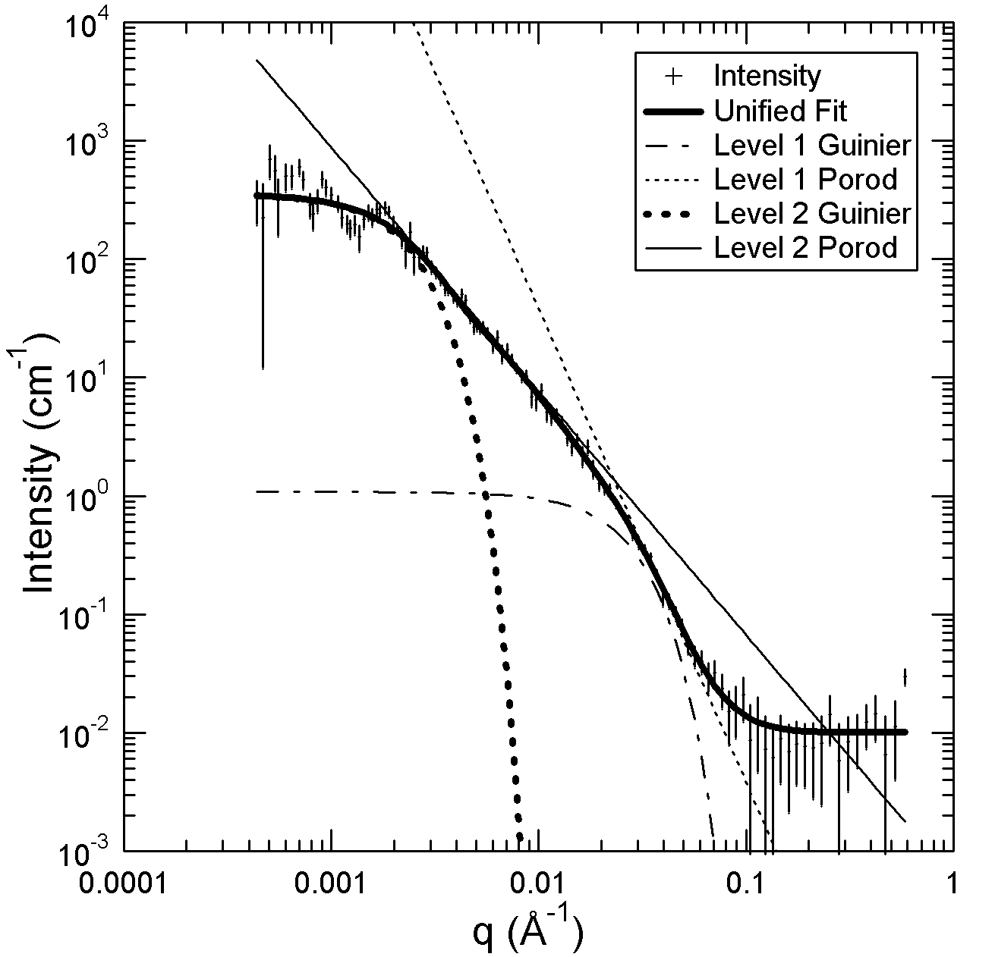

Figure 9. In situ USAXS pattern from UNICAT at APS taken on a flame used to synthesize nanoparticles (volume fraction 10-6) 5mm LAT 16mm HAB. Data shows a typical branched aggregate, d_{p} = 5.7 nm,z = 350,c = 1.5, d_{min} = 1.4, d_{f} = 2.1, φ_{br} = 0.8 [25,26].

Figure 10 shows how the branching and dimensional aspects of aggregates might be expected to evolve in an aerosol growth process for nanoparticles. For the simulation results shown aggregates and primary particles grow (not shown) while the mass fractal dimension weakly drops in time, the branch content increases with an increasing connectivity dimension and a decreasing minimum dimension.
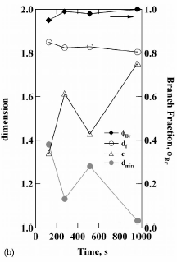
Figure 10. Aggregate Structure as a function of time in a reacting system (shown here is a simulation) [25].

Specific Surface Area and Sauter Mean Diameter: While the radius of gyration from equation (4) reflects the ratio of high order moments, and so reflects the size for the largest particles in a distribution, it is possible to obtain other moments of the particle size distribution from the scattering pattern without assuming a particle size distribution function. The lowest order moment that can be obtained directly from SAXS is the ratio of the third to second moment of size, or the ratio of the mean particle volume to the mean particle surface area. If the composition of scattering elements and the matrix in which they are immersed are known then the Porod prefactor, B, from equation (5) can be used directly to obtain V/S, also called the Sauter mean diameter, d_{p}. Generally, the assumptions involved in a direct calculation do not need to be made since the scattering invariant, Q, can be calculated and used to normalize B,

$Q=q=\int_{q=0}^{∞}{q^{2}I\left(q\right)\text{dq}=2π^{2}{Nρ}_{e}^{2}V=2π^{2}N\frac{n_{e}^{2}}{V}}$ (11)

The invariant should be calculated only for that part of the scattering pattern associated with the primary particles, Figures 7 and 11. For aggregate particles the unified function can be used to separate scattering from primary particles and aggregate correlations, however, for non-aggregated particles a concentration factor might be needed in some cases to account for primary particle correlations [21-23,27].

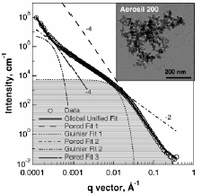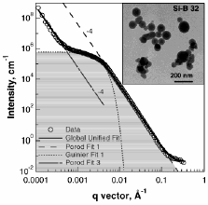
Figure 11. a) Aggregated and b) non-aggregated silica. Region for integral is shown from [27].

Figure 12 demonstrates the agreement between d_{p} from SAXS and from gas absorption for aggregated silica, 12a) and from non-aggregated silica 12b). Generally agreement is acceptable both for aggregated and non-aggregated particles with better agreement for aggregated particles where particle correlations are accounted for in the unified analysis.

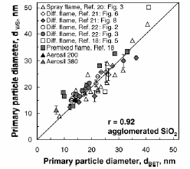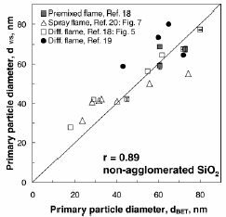
Figure 12. Sauter mean diameter from SAXS (left) and from gas absorption (bottom). a) Agglomerated silica, b) non-agglomerated silica. From [27].

Particle Size Distributions: In addition to particle size it is possible to determine the particle-size distribution using SAXS and SANS. Figure 13, for example shows the use of a regularization technique [28,29] to transform ASAXS data to a particle size distribution curve based on summation of sphere scattering functions

$I\left(q\right)=9G{\left[\frac{\text{sin}\text{qR}−\text{qR}\text{cos}\text{qR}}{{\left(\text{qR}\right)}^{3}}\right]}^{2}$ (12).

for each particle size, R, in a particle size distribution, P(R).

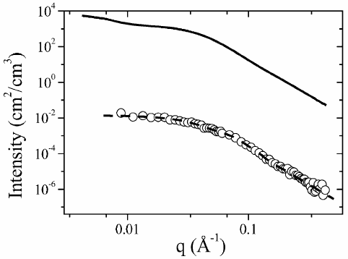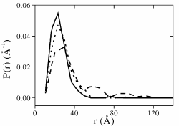
Figure 13. a) ASAXS data, b) particle size distribution using sphere functions and renormalization approach [30] from [29].

Particle size distributions can be obtained using a variety of techniques, for example:

Assumption method: Assume a distribution assume a particle shape, minimize.
Unified Method: Obtain generic factor directly from scattering, PDI
Convert PDI to distribution curve based on assumed distribution function
[21].
Maximum Entropy (and Regularization) techniques: Complex conversion with somewhat vague
constants that modify the particle-size distribution curve. Generally can
exactly reproduce the particle size distribution. Weak understanding of
the relationship between features in the data and features in the particle
size distribution [21,28-30].

In the first method a particle scattering function such as the sphere function is assumed and a distribution function such as the Gaussian distribution, the Schultz distribution or the log-normal distribution is arbitrarily chosen. Initial parameters are guessed from an inspection of the data and the distribution function is minimized against the scattering data. The result is not unique and could be significantly erroneous especially if the data displays multiple modes or other features that differ from the assumed distribution function.

For the unified method, the polydispersity index, PDI, is calculated directly from the scattering data [21]. PDI is sensitive to both assymmetry of the particles as well as polydispersity. Polydispersity of primary particles is recognizable in the scattering curve as an increase in the power-law scattering intensity relative to Guinier scattering.

$\text{PDI}=\frac{{\text{BR}}_{g}^{4}}{1\text{.}\text{62}G}$ (13)

The generic quantification of polydispersity and asymmetry in PDI can be converted to a distribution, most conveniently the log-normal distribution. For a log-normal distribution of particles the standard deviation, σ, and geometric standard deviation, σ_{g}, in particle size is given by,

$σ=\text{ln}σ_{g}={\left(\frac{\text{ln}\text{PDI}}{\text{12}}\right)}^{12}$ (14)

and the mean, m, is given by,

$m={\left(\frac{5R_{g}^{2}}{3e^{\text{14}σ^{2}}}\right)}^{12}$ (15)

Figure 14 shows a comparison of the unified approach using PDI and particle counting using TEM as well as the Maximum Entropy method for conversion of SAXS data to particle size distribution [21,30-35]. The maximum entropy method does not assume a particle size distribution but rather assumes that the particle size distribution that best represents the scattering data is one with the most random residual difference between the calculated and measured data. This constraint replaces the assumption of a distribution function in determining the particle size distribution. Features in the distribution such as the number and size of virtually any number of modes can be determined using the Maximum Entropy method, see Fig. 14b for example.

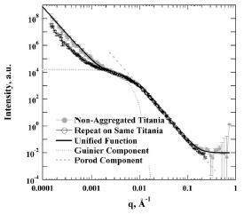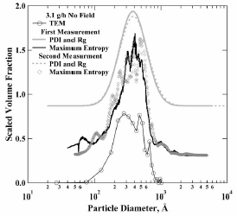
Figure 14. a) Duplicate USAXS measurements for demonstration of reproducibility of scattering analysis of particle polydispersity distribution curves. b) Distribution curves calculated by Unified method using PDI, Maximum Entropy method and by particle counting using TEM images. From [21]

Correlation Analysis: Figure 6 shows two examples of correlated systems with the simplest type of correlation involving spherically symmetric correlations described by a correlation distance, ξ, and a packing factor, p.

$I\left(q,G,B,R,p,ξ\right)=F{\left(q,G,B,R\right)}^{2}S\left(q,p,ξ\right)=\frac{F{\left(q,G,B,R\right)}^{2}}{1+pθ\left(q,ξ\right)}$ (16)

where,

$θ\left(q,ξ\right)=3\frac{\text{sin}\left(qξ\right)−qξ\text{cos}\left(qξ\right)}{{\left(qξ\right)}^{3}}$ (17)

corresponds to the amplitude function for spherically arranged correlations. p is equal to 8 times the ratio of the average hard-core volume of a domain to the free-volume available to a domain (a larger number). For dilute conditions the free volume is infinite and p is 0. The correlation distance corresponds to the mean separation distance for domains while the packing factor is a measure of the regularity and density of packing, for example, for a closest packed FCC structure, p = 5.92 which is the highest value for spherically symmetric correlations of spheres. For asymmetric objects such as rods or platelets a much higher value for p is possible. For a dilute system p = 0. This approach using the unified function for F(q)² is described in [36].
Correlations of asymmetric particles and domains such as block co-polymers, micelles, synthetic zeolites such as MCM-41 [37,38], and polymer lamellar crystals are best described either through a diffraction peak analysis, through the use of a Fourier transform of the scattering data or through reduction in the dimensionality of scattering by multiplication of I(q) by q^{df} where d_{f} is the mass-fractal dimension of the correlating objects [39].

Analysis/Reduction of GISAXS Data: Grazing incidence SAXS involves a thin film sample, with in-plane structure such as palladium domains deposited on a silica native oxide layer [47]. For catalysis research GISAXS offers the opportunity to examine samples prepared for spectroscopic characterization or for multiple detector measurements, Figure 15 b. In situ studies of nano-catalyst domain growth have been recently completed [40,41]. Generally structural information is limited to measurement of the radius of gyration of nano-scale domains even in the most ideal circumstances since the GISAXS pattern is rather complicated. The analysis of GISAXS data has been worked out in detail only for restricted structural shapes such as pyramids, and truncated pyramids [41,42] General solutions to GISAXS scattering patterns have proven elusive despite great promise and exciting qualitative information such as real time movies of pattern changes with nano-structural growth in thin films during CVD growth of domains.
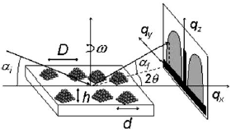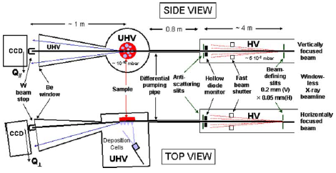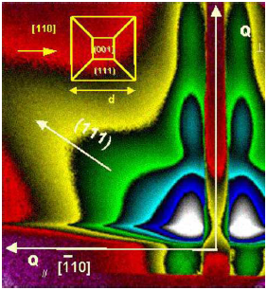
Figure 15. a) Geometry for GISAXS measurement. b) Camera geometry for GISAXS c) GISAXS pattern showing lateral peaks associated with periodic spacing of Pt domains, vertical peaks associated with domain height, off angle intensity due to 111 planes of Pt. From [43,44].

Analysis/Reduction of ASAXS Data: Anomalous small-angle X-ray scattering (ASAXS) involves measurement of a traditional SAXS pattern using one of the SAXS cameras described above except with a tunable incident/detected X-ray energy. Energies near the absorption edge of a transition metal are used. Figure 16b, for example, shows a plot of the absorption f" and elastic f'' form factor (contrast) for platinum, Pt, near the absorption edge. While the absorption form factor goes through a step change at the absorption edge, the elastic form factor shows a gradual change allowing the subtraction of two measurements near the L₃ absorption edge to isolate the scattering component associated with platinum, in this case.
ASAXS can be used to selectively distinguish scattering from a catalytic transition metal from that of the substrate or other background, Figure 18 shows nickel catalyst on alumina for instance. The approach works best for a two component system where the scattering and absorption structure factor (chemical composition) are known for the two components. For any given value of scattering vector, q, the scattered intensity is composed of scattering from the catalyst domains, scattering from the substrate and structural effects of the catalyst domains on the substrate and visa versa. Generally, the latter structural features are ignored.
For instance, if nickel particles were located on the surface of alumina spheres, the arrangement of nickel domains would not be random in space. The organization of nickel particles due to alumina could not be subtracted from the scattering data by subtraction of alumina scattering. Similarly, if nickel at the surface of the alumina particles modifies the interaction between alumina domains the correlation effect of nickel on alumina could not be subtracted by subtraction of nickel scattering. Nonetheless, ASAXS has proven to be an extremely powerful technique for understanding particle growth and structural changes through catalytic cycles.

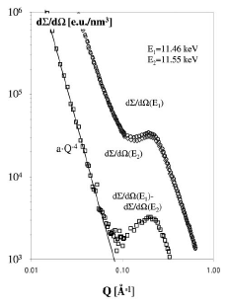
Figure 16. Pt/biphenyl hybrid particle scattering at two energies near the absorption edge of Pt [45]. This data uses the L₃ absoption edge rather than the K-edge used in figures 17 and 18.

The situation can also become complex when more than two components of unknown composition are present in the same sample. Generally, better results will be obtained from the use of more than two wavelengths, each wavelength contributing one degree of freedom per q channel in the data. For instance for a nickel catalyst supported on alumina with an air background or an organic fluid background it would be desirable to measure scattering for at least three wavelengths near the nickel absorption edge, Figure 18. ASAXS and AWAXS [46] have enormous potential in heterogeneous (as well as homogeneous in some cases) catalysis if used carefully and with some consideration of possibly misleading results due to improper consideration of the composition of the system. For this reason it is important to check results with multiple wavelength measurements.
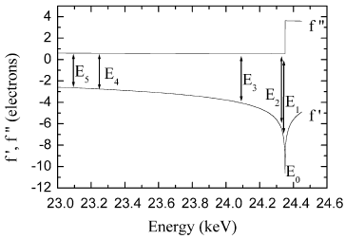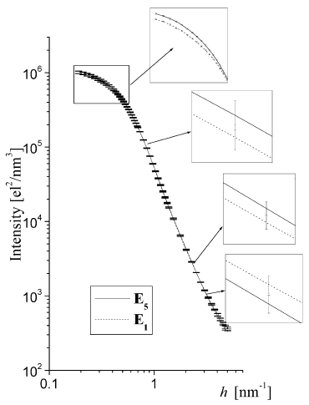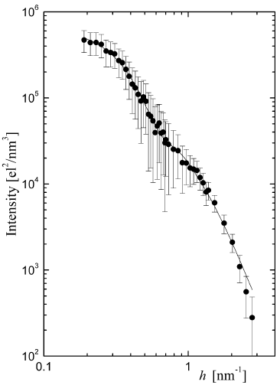
Figure 17. Pd supported on SiO₂. TEM shows Pd with two size populations as supported by the two knees in the scattering pattern. h = q. From [47].

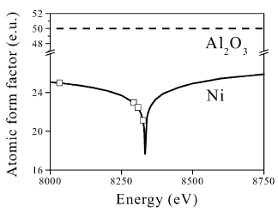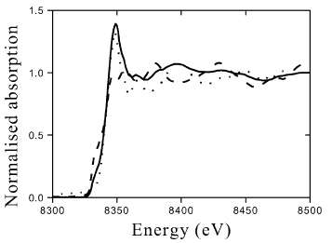
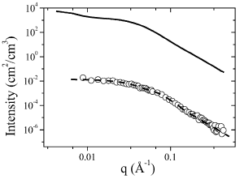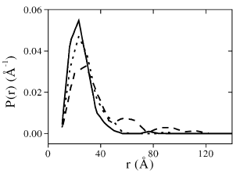
Figure 18. Ni on Alumina support. From [28]

Analysis/Reduction of SANS Data: This seems to be for Thiyaga Both spectroscopy and SANS/wide angle are appropriate since these are all under utilized techniques.

Suggested/Sample of Software for Data Analysis: Many options are available for data reduction and modeling for heterogeneous catalysts. The most useful options are cross platform compatible and can be modified for specific tasks. NIST Software package
http://www.ncnr.nist.gov/programs/sans/data/data_anal.html,
UNICAT Software package for ASAXS and SAXS
http://www.uni.aps.anl.gov/usaxs/

UNICAT Software: An example of a typical shareware data reduction package is the data reduction package prepared by Jan Ilavsky and Pete Jemian at APS. The software package operates in the Igor platform and includes a detailed manual and a frequently updated web page and includes support for ASAXS and SAXS.

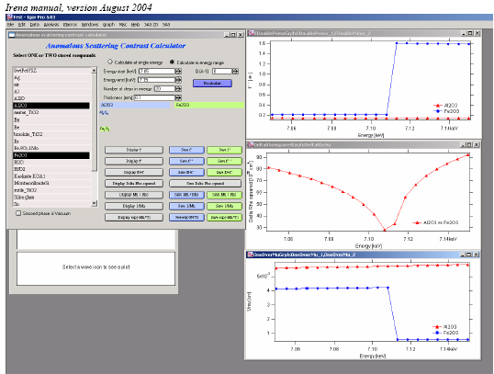
Figure 19. Calculation of the scattering and absorption coefficients using UNICAT APS software.

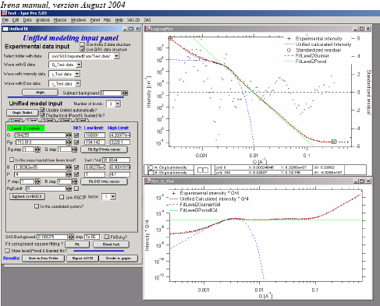
Figure 20. Data fitting using UNICAT software.

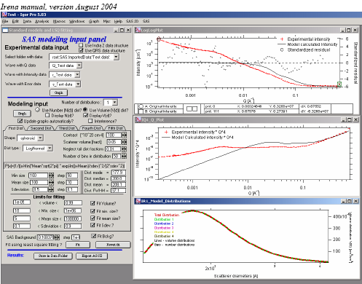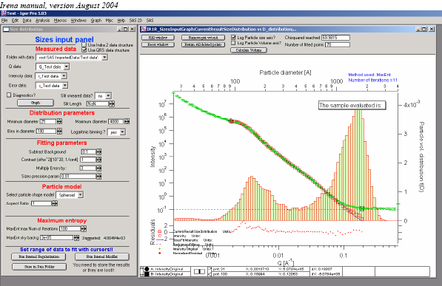
Figure 21. Calculation of the particle size distribution using the UNICAT software. a) using assumption method and b) using regularization or maximum entropy methods.

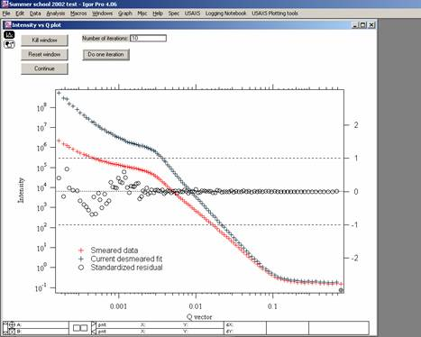
Figure 22. Lake-method for desmearing in the UNICAT software package.

IPNS Software (SANS): Thiyaga

NIST Software (SANS): Is anyone familiar with this? Otherwise dump this section.

Summary: Small-angle X-ray and neutron scattering offer information concerning structural development and control on the nano- to colloidal scales. SAXS Measurement is generally easy and adaptable to a wide range of sample environments including high vacuum measurements. It is possible to perform SAXS in reflection mode using grazing incidence beam although quantitative analysis of such GISAXS data is non-trivial. The use of anomalous scattering near the absorption edge of catalytic metals is of great use in SAXS measurements of heterogeneous catalysts though it is not totally necessary to use ASAXS and much information can be ascertained using fixed wavelength lab sources. For in situ studies, or studies using variable wavelength such as ASAXS a synchrotron is a necessity.

References:

1) Model studies in heterogeneous catalysis. From Structure to Kinetics. Libuda J, Schauermann S, Laurin M, Schalow T, Freund HJ Monatshefte fur Chemie 136 59-75 (2005).
2) Electronic structure and catalysis on metal surfaces. Greeley J, Norskov JK, Mavrikakis M, Annu. Rev. Phys. Chem. 53 319-348 (2002).
3) Onset of catalytic activity of gold clusters on titania with the appearance of nonmetallic properties. Valden M, Lai X, Goodman DW Science 281 1647-1650 (1998).
4) Gold Catalysts prepared by coprecipitation for low-temperature oxidation of hydrogen and of carbon monoxide. Haruta M, Yamada N, Kobayashi T, Iijima S, J. Catalysis 115 301-309 (1989).
5) Size- and support-dependency in the catalysis of gold. Haruta M Catalysis Today 36 153-166 (1997).
6) Ceramics for catalysis, Kean MA J. Materials Science 38 4661-4675 (2003).
7) Limits and advantages of X-ray absorption near edge structre for nanometer scale metallic clusters. Bazin D and Rehr JJ J. Phys. Chem. B 107 12398-12402 (2003).
8) Guinier A & Fournet G Small Angle Scattering of X-rays, John Wiley & Sons NY (1955).
9) Porod G Chapter 2: General Theory in Small Angle X-ray Scattering eds. Glatter O & Kratky O, Academic Press NY (1982).
10) From small angle x-ray scattering to reflectivity: Instrumentation and sample study. Hua DW, Beaucage G, Kent MS J. Mat. Res. 11 273-276 (1996).
11) Lake Method of Desmearing
12) Schmidt Method of Desmearing
13) The Ultra-Small-Angle X-ray Scattering Instrument on UNICAT at the APS, Long GG, Allen AJ, Ilavsky J, Jemian PR, and Zschack, P in SRI99: Eleventh U.S. National Synchrotron Radiation Instrumentation Conference, AIP Conference Proceedings CP521, editors P. Pianetta, J. Arthur, and S. Brennan, Stanford Linear Accelerator Center, Stanford, CA, 2000 (New York: American Institute of Physics), pp. 183-187.
14) Web links to APS DND, ESRF ID02
15) Web links to Chess, UNicat and HasyLab.
16) JUSIFA - a new user dedicated ASAXS beamline for materials science. Haubold HG, Gruenhagen K, Wagener M, Jungbluth H, Heer H, Pfeil A, Rongen H, Brandenburg G, Moeller R, Matzerarth J, Hiller P, Halling H Rev. Sci. Instrum. 60 1943 (1989).
17) BioCat APS web page
18) http://www.gkss.de/pages.php?page=w_abt_genesys_sans-1.html&language=d&version=g
19) Structural studies of complex systems using small-angle scattering - a unified Guinier power-law approach. Beaucage G, Schaefer DW J. Non-Cryst. Solids 172 797-805 (1994).
20) Approximations leading to a unified exponential power-law approach to small-angle scattering. Beaucage G J. Appl. Cryst. 28 717-728 (1995).
21) Particle size distributions from small-angle scattering using global scattering functions. Beaucage G, Kammler HK, Pratsinis SE J. Appl. Cryst. 37: 523-535 (2004).
22) Vergleichende Rontgenographische und elektronenmikroskopishe untersuchungen der grosse von Gunier-Preston-zonen in aluminium-silber. Bauer R & Gerold V Acta Metal. 12 1449-1453 (1964).
23) Other Reference from G. Kostov in Kratky Book Chapter.
24) Small-angle scattering from polymeric mass fractals of arbitrary mass-fractal dimension. Beaucage G J. Appl. Cryst. 29 134-146 (1996).
25) Determination of branch fraction and minimum dimension of mass-fractal aggregates. Beaucage G Phys. Rev. E 70Art. No. 031401 (2004).
26) Monitoring simultaneously the growth of nanoparticles and aggregates by in situ ultra-small-angle x-ray scattering. Kammler HK, Beaucage G, Kohls DJ Agashe N, Ilavsky J J. Appl. Phys. 97 054309 (2005).
27) Structure of flame made silica nanoparticles by ultra-snall-angle x-ray scattering. Kammmler HK, Beaucage G, Mueller R, Pratsinis SE Langmuir 20 1915-1921 (2004).
28) Sintering of Ni/Al2O3 catalysts studied by anomalous small angle x-ray scattering. Rasmussen RB, Sehested J, Teunissen HT, Molenbroek AM, Clausen BS Applied Catalysis A. 267 165-173 (2004).
29) Determination of size distributions from small-angle scattering data for systems with effective hard-sphere interactions. Pedersen JS J. Appl. Cryst. 27 595-608 (1994).
30) Characterization of 9CR-1 MoVnB Steel by Anomalous small-angle X-ray scattering Jemian PR, Weertman JR, Long GG, Spal RD Acta Metall. Mater. 39 2477-2487 (1991).
31) Maximum entropy image reconstruction-general algorithm. Skilling J, Bryan RK Monthly Notices R. Astronom. Soc. 211 111-124 (1984).
32) Polydispersity during the formation and growth of the Stober silica particles from small-angle X-ray scattering measurements. Boukari H, Long GG, Harris MT J. Colloid Interface Sci. 229 129-139 (2000).
33) On uncertainty in maximum-entropy maps and the generalization of classic maxent. Hansen S, Wilkons SW Acta Cryst. A50 547-550 (1994).
34) The determination of particle-size distributions in small-angle scattering using the maximum-entropy method. Morrison JD, Corcoran JD, Lewis KE J. Appl. Cryst. 25 504-513 (1992).
35) Particle-size distributions from SANS data using the maximum entropy method. Potton JA, Daniell, GJ Rainford BD J. Appl. Cryst. 21 663-668 (1988).
36) G. Beaucage, T. A. Ulibarri, E. P. Black, D. W. Schaefer, "Multiple Size Scale Structures in Silica-Siloxane Composites Studied by Small-Angle Scattering" Chapter 9, Hybrid Organic-Inorganic Composites Eds. J. E. Mark C. Y-C Lee, P. A. Bianconi ACS symposium series 585 1995 San Diego Ca.
37) Ordered mesoporous molecular sieves synthesized by a liquid crystal template mechanism, Kresge CT, Leonowicz ME, Roth WJ, Vartuli JC, Beck JS Nature 359 710-712 (1992).
38) A new family of mesoporous molecular sieves prepared with liquid crystal templates. Beck JS, Vartuli JC, Roth WJ, Leonowicz ME, Kresge CT, Schmitt KD Chu CTW, Olson DH, Sheppard EW, Mccullen SB, Higgins JB, Schlenker JL, J. Am. Chem Soc. 114 10834-10843 (1992).
39) R. J. Roe, Methods of X-ray and Neutron Scattering in Polymer Science, Oxford University Press, NY (2000).
40) Thermal Stability of Supported Platinum Clusters Studied by in situ GISAXS. Winans RE, Vajda S, Lee B, Riley SJ, Seifert S, Tikhonov GY, Tomczyk NA J. Phys Chem B 18105-18107.
41) Flat-top silver nanocrystals on the two polar faces of ZnO: an all angle x-ray scattering investigation. Jedrecy N, Renaud G, Lazzari R, Jupille J Phys. Rev. B 72 045430-1 to 045430-14 (2005).
42) Quantitative analysis of grazing incidence small-angle x-ray scattering: Pd/MgO (001) growth. Revenant C, Leroy F, Lazzari R, Renaud G, Henry CR Phys. Rev. B 69 035411 1-17 (2004).
43) Apparatus for real time in situ quantitative studies of growing nanoparticles by grazing incidence small angle X-ray scattering and surface differential reflectance spectroscopy Renaud G, Ducruet M, Ulrich O, Lazzari R Nucleat Instr. and Meth. in Phys. Res. B 222 667-680 (2004).
44) Real-time monitoring of growing nanoparticles. Renaud G., Lazzari R, Revenant C., Barbler A, Noblet M, Ulrich O, Leroy F, Jupille J, Borensztein Y, Henry CR, Deville J-P, Scheurer F, Mane-Mane J, Fruchart O Science 300 1416-1419 (2003).
45) Three-dimensional Pt-nanoparticle networks studied by anomalous small-angle X-ray scattering and X-ray absorption spectroscopy, Vad T, Haubold H-G, Waldofner N Bonnemann H J. Appl. Cryst. 35 459-470 (2002).
46) Anomalous wide angle X-ray scattering (AWAXS) and heterogeneous catalysts, Bazin D, Guczi L, Lynch J Applied Catalysis A: General 226 87–113 (2002).
47) Quantitative investigations of supported metal catalysts by ASAXS Polizzi S. , Riello P. , Goerigk F., Benedetti A J. Synchrotron Rad. 9 65-70 (2002).

