Introduction to Heat Transfer
Heat can be transferred to or from a material in three fundamental ways; conduction, convection, and/or radiation. Any and all of the three types of heat transfer can occur for a system, so one must be careful not to neglect any heat transferred during the process.

In conduction, heat is transferred from one part of a body to another part of that same body, or between bodies that are in contact with each other without any appreciable displacement of the particles within the body. The discussion on conduction will begin with Fourier’s Law, which allows for equations to be derived for steady state uniaxial heat transfer. A simplified equation that can be used in the event that heat is not generated (via chemical or nuclear reactions or electrical current) will also be presented. Finally, equations for heat transfer through bodies in series and bodies in parallel will be given. Due to the level of complexity, unsteady state conduction is outside of the scope of this site, and generally involves advanced algorithms and assistance from computer software. These systems are indicative of materials whose temperatures change with respect to both time and position. Some references will be given for those readers interested can pursue at their leisure.

In convection, heat is transferred from one point to another through a moving fluid, most likely a gas or liquid, as a result of the mixing of different portions of the fluid. There are two sub-segments of convection, natural and forced. In natural convection, the motion of the fluid is the inherent result of the density gradient that results from the temperature differential. In forced convection, the motion of the fluid is the result of some mechanical work, such as a blow or pump moving the fluid across the material.

Heat is transferred through radiation from one body to another by means of wave motions through space.

Conduction
In some polymer process, such as injection molding, blow molding, cast films, extrusion coating, and rotational molding, heat is quickly removed from the molten polymer by contacting it with a cold body, such as a water cooled mold or chill roll. This process of quickly cooling the polymer is characterized by heat transfer through conduction.

Fourier’s Law
The fundamental differential equation for conduction heat transfer is Fourier’s Law, which states:
$$\frac{\text{dQ}}{\text{dt}}=−\text{kA}\left(\frac{\text{dT}}{\text{dx}}\right)$$
Where Q is heat, t is time, k is the thermal conductivity, A is the area normal to the direction of heat flow, T is temperature, and x is distance in the direction of heat flow. At this point, it is worth noting that the thermal conductivity typically varies with temperature, but not necessarily in the same direction. A common simplification in heat transfer calculations is to assume this term is constant within the conditions of the system under study. It is strongly suggested investigate literature, obtain values from material vendors, or carefully conduct calorimetric testing within one’s lab to determine the proper values for k for the given material as a function of temperature, especially if a phase transition occurs within the range of temperatures under study.

Using Fourier’s Law, we can write an expression for a three dimensional unsteady-state energy equation for a solid.
$$cρ\frac{δT}{δt}=\frac{δ}{δx}\left(k\frac{δT}{δx}\right)+\frac{δ}{δy}\left(k\frac{δT}{δy}\right)+\frac{δ}{δz}\left(k\frac{δT}{δz}\right)+q_{\text{gen}}$$
Where c is the specific heat of the material, ρ is the density of the material, T is temperature, t is time, x,y, & z are distances in Cartesian coordinates, and q_{gen} is the rate of heat generated per unit volume, typically by chemical or nuclear reactions or electrical current. This equation will serve as the basis for solving steady state heat transfer problems.

Steady State Conduction
In steady state conduction, the rate of heat transferred relative to time (δQ/δt) is constant and the rate of change in temperature relative to time (δT/δt) is equal to zero. For heat transfer in one dimension (x-direction), the previously mentioned equations can be simplified by the conditions set fourth by steady-state to yield:
$$\frac{δ^{2}T}{{δx}^{2}}=−\frac{1}{k}\left(\frac{\frac{δQ}{δt}}{δx}\right)$$
Similar relationships can be derived for other coordinate systems including:
Cylindrical
$$\frac{1}{r}\frac{d}{\text{dr}}\left(r\frac{\text{dt}}{\text{dr}}\right)=−\frac{1}{k}\left(\frac{\frac{δQ}{δt}}{δr}\right)$$
Spherical
$$\frac{1}{r^{2}}\frac{d}{\text{dr}}\left(r^{2}\frac{\text{dt}}{\text{dr}}\right)=−\frac{1}{k}\left(\frac{\frac{δQ}{δt}}{δr}\right)$$

Upon integration of these second order differential equations, the following are obtained:
Cartesian:
$$T=−\frac{\left(\frac{\frac{δQ}{δt}}{δx}\right)x^{2}}{2k}+c_{1}x+c_{2}$$
Cylindrical
$$T=−\frac{\left(\frac{\frac{δQ}{δt}}{δr}\right)r^{2}}{4k}+c_{1}\text{ln}r+c_{2}$$
Spherical
$$T=−\frac{\left(\frac{\frac{δQ}{δt}}{δr}\right)r^{2}}{6k}+\frac{c_{1}}{r}+c_{2}$$

In the event that heat is not generated in the system of interest, (δQ/δt)/δx is equal to zero. For a steady state, one dimensional system, Fourier’s law can be integrated to give:
$$q\int_{x_{1}}^{x_{2}}{\frac{\text{dx}}{A}}=−\int_{T_{1}}^{T_{2}}{\text{kdT}}$$
Where q is the rate of heat transfer (δQ/δt) to/from the system. To correctly solve this equation, the area (A) through which the heat is being transferred must be known as a function of position (x). In the event that k is a constant, the integration of the above equation results in:
$$q=−{\text{kA}}_{\text{avg}}\frac{ΔT}{Δx}$$
Where A_{avg} is calculated by:
$$A_{\text{avg}}=\frac{1}{Δx}\int_{x_{1}}^{x_{2}}{\frac{\text{dx}}{A}}$$
The following table gives some equations to calculate A_{avg} based on the relationship between A and x:
Area (A) is proportional to: | A_{avg} is equal to:
Constant | A₁=A₂
x | $$\frac{A_{2}−A_{1}}{\text{ln}\left(\frac{A_{x}}{A_{1}}\right)}$$
x² | $$\sqrt{\frac{A_{2}}{A_{1}}}$$

Conduction through Bodies in Series
The following figure shows the temperature gradient through three solid bodies in series:
Insert series figure
For this arrangement, the heat through the three bodies is equivalent (assuming steady state). This means that the following equation is can be used to determine the heat flow through the system:
$$q=k_{1}A_{1}\frac{{\text{dT}}_{1}}{{\text{dx}}_{1}}=k_{2}A_{2}\frac{{\text{dT}}_{2}}{{\text{dx}}_{2}}=k_{3}A_{3}\frac{{\text{dT}}_{3}}{{\text{dx}}_{3}}$$
Next, a new term, the thermal resistance (R) is defined as:
$$R=\frac{x}{\text{kA}}$$
Rearranging Fourier’s Law, we obtain:
$$ΔT=\text{qR}$$
As stated earlier, the heat transfer (q) is uniform, so the total temperature drop from one edge of the system to the other is equivalent to the summation of the temperature drops of each sub-segment within the system, resulting in:
$${ΔT}_{\text{total}}=\sum{{ΔT}_{i}=}q\sum{R_{i}}={\text{qR}}_{\text{Total}}$$
Where R_{total} is the total thermal resistance of the system. The above equation provides a means of calculating the expected amount of heat transferred through a multilayer system in series if the properties of the inherent characteristics of the materials (thermal conductivities), dimensions of each layer (thickness and normal cross sectional area) and the temperature gradient across the system are known.

Conduction through Bodies in Parallel
For a series of elements arranged in parallel, as shown in the following figure, the amount of heat transferred through the system is equivalent to the additive sum of the heat transferred though each component.
$$q_{\text{total}}=\sum{\frac{{ΔT}_{i}}{R_{i}}}$$
Assuming steady state and that the temperatures on each side of the system are uniform across the cross sectional area normal to the heat flow:
$$q_{\text{total}}={ΔT}_{i}\sum{\frac{1}{R_{i}}}={ΔT}_{i}\sum{C_{i}}$$
Where C is the conductance of the material and is calculated by:
$$C=\frac{\text{kA}}{x}$$
Caution should be used when applying this analysis to systems that generate heat, such as that resulting from a chemical reaction. In the event that heat is generated by one of the materials in the system, the differential equations previously mentioned that relate temperature (T) to position (x) must be solved with appropriate boundary conditions.

Convection
In some polymer process, such as blown film or water quenched film or pelletization, heat is removed from the polymer by passing a cold fluid, such as air or water, over the surface of the molten polymer. This process of cooling the molten polymer is characterized by heat transfer through convection. This section will discuss the transfer of heat through both natural convection and forced convection by utilizing individual and overall coefficients of heat transfer.

The convection heat transfer process can be described by discussing the following figure:
Insert fig similar to 5-6 of Perry’s
Two fluids are present with Fluid 1 representing the hot polymer and Fluid 2 representing the cooling fluid, say cooling air. The temperatures of the two fluids are indicated respectively as T₁ and T₂, with T₁ > T₂. As one moves away from the core of the hot polymer sample, a scale layer of thickness x is observed, which is representative of the crystallized polymer. In a dynamic model, this scale layer is a function of both time and temperature gradient between the cooling medium and the molten polymer. To fully incorporate the effects of this scale layer, the conduction of heat from the molten core to the sale must be included and information regarding the crystallization rate, thermal conductivities, and specific heats with respect to temperature would be needed. This analysis can become extensive and is outside the scope of this exercise, so we focus on the heat transferred between a molten polymer and a fluid in a quenched process. To do so, we assume that the crystallization process is instantaneous and the thermal properties (thermal conductivity, specific heat) are identical for the molten and solid polymer and for all practical purposes; do not change with respect to temperature as a result of the rapid cooling process. In addition, we assume that the amount of cooling fluid is significantly greater than the amount of hot polymer so that heating of the cooling medium from the release of latent heat from the crystallization of the polymer can be neglected.

For our simplified model, we see the fluid consists of two layers: a laminar film located on the surface of the hot polymer and a turbulent layer outside of the laminar film in the body of the cooling medium. In this laminar layer, heat is only transferred through molecular conduction, significantly reducing the heat transfer between the hot and cold mediums. The heat resistance of the laminar layer is related to its thickness and thermal properties. Moving away from the laminar flow, a layer exists where the flow is becoming more turbulent at distances further away from the hot body until the area of turbulent flow. The heat resistance of the turbulent area is a function of the turbulence and thermal properties of the fluid.

The system just described is extremely complicated and difficult to model without extensive fluid mechanics calculations. In addition, it is unpractical to expect to measure the thicknesses and temperatures of the various layers in the flowing fluid, so a simplified technique will be presented that calculates the local rate of heat transfer between the fluids, which is given by:
$$\text{dq}=h_{\text{inside}}{\text{dA}}_{\text{inside}}(T_{\text{fluid}}−T_{\text{inside}})=h_{\text{outside}}{\text{dA}}_{\text{outside}}(T_{\text{outside}}−T_{\text{fluid}})$$
where T_{inside}, T_{outside}, A_{inside}, A_{outside}, h_{inside}, and h_{outside} are the temperatures, areas, and local heat transfer coefficients inside and outside the wall of the polymer body. T_{fluid} is the temperature of the cooling fluid (also previously called T₂). Differentiation of the above equation gives the heat transfer in terms of the temperature gradient through the wall between the two fluids. It is typically impractical to measure these intermediate temperatures and a more desirable method that only requires the bulk temperatures of the two fluids is desirable. This leads to the development of a model that incorporates an overall coefficient of heat transfer.

The overall transfer of heat between materials can be characterized by an overall heat transfer coefficient, h. This coefficient is based on an area conveniently defined by the system, dA. We now define the local heat transfer about the chosen area by the general convection heat transfer equation:
$$\text{dq}=\text{hdA}(T_{\text{fluid}}−T_{\text{polymer}})$$
where T_{polymer} is the bulk temperature of the molten polymer eand T_{fluid} is the temperature of the outside fluid.

Before moving forward, the concept of the Reynolds number (Re), Prandtl number (Pr), Grashof number (Gr), and Nusselt number (Nu) needs to be introduced, which are dimensionless terms used to determine the overall convection heat transfer coefficient, h.

The Reynold’s number is indicative of the type of flow, laminar or turbulent, that is present in the system and is calculated by:
$$\text{Re}=\frac{ρ\text{ux}}{μ}$$
where x is the position along the interface in the direction of fluid flow, u is the velocity, ρ is the density, and μ is the viscosity of the fluid. If Re is less than 5*10⁵-5*10⁶, the flow is considered linear. Values greater are indicative of turbulent flow.

The Prandtl number is calculated by:
$$\text{Pr}=\frac{υ}{α}=\frac{c_{p}μ}{k}$$
where for the fluid, ν is the kinematic viscosity, α is the thermal diffusivity, c_{p} is the specific heat, and k is the heat transfer coefficient.

The Grashof number, which is used in natural convection, and is calculated by:
$$\text{Gr}=\frac{gβ(T_{w}−T_{∞})x^{3}}{υ^{3}}$$
where g is the gravitational constant, β is the volume coefficient of expansion (for an ideal gas, β=T⁻¹), T_{w} is the temperature at the interfacial wall between the fluids, and T∞ is the temperature of the moving fluid.

The Nusselt number is calculated by:
$$\text{Nu}=\frac{\text{hx}}{k}=f(\text{Pr,Re,}\text{Gr})$$

The typical procedure is to calculate Pr, Re, and Gr and characterize the geometry and flow conditions about the interface of the two materials, then select the proper function (Nu(Pr,Re,Gr)) for the Nusselt number.

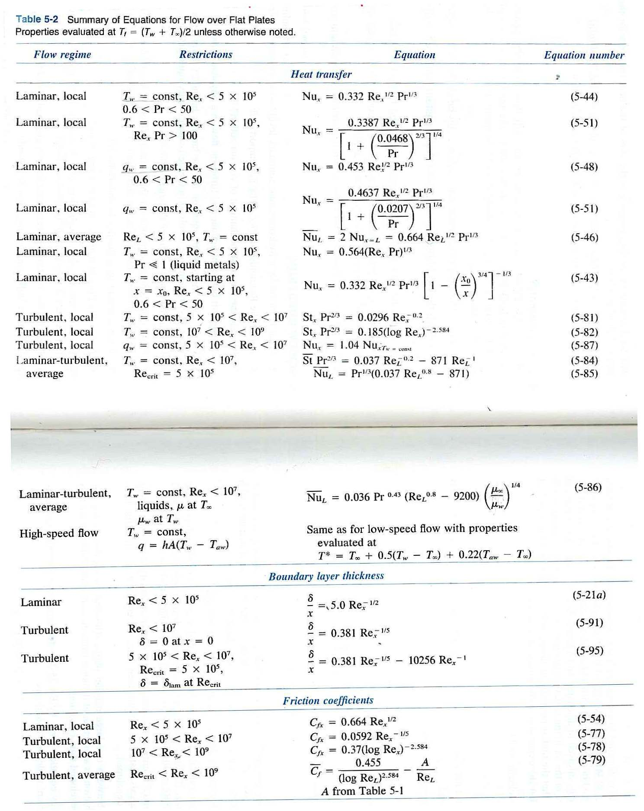
Next, the Nusselt number equation is solved for h, which is then substituted into the general convection heat transfer equation.

Radiation
Thermal radiation is electromagnetic radiation with a wavelength between 700 nm and 10⁵ νμ. If we note α as the fraction of energy being absorbed (absorptivity), ρ as the fraction being reflected (reflectivity) and τ as the fraction being transmitted through (transmissivity), the radiation conversion law states:
$α+ρ+τ=1$
For some boundary cases, such as opaque solids and some liquids, τ = 0, while gases reflect little radiant energy, so ρ = 0.

At this point, the black body will be introduced. A black body is an ideal radiator, which means it absorbs all the energy that is impinged upon it (α = 1) and also emits the maximum possible energy when acting as a source. A black body is a theoretical entity which is never achieved in practice (much like an ideal gas).

Real bodies are known as grey bodies, and are characterized by their emissivity, ε, which is defined as:
$$ε=\frac{q_{\text{grey}}}{q_{\text{black}}}$$
which is simply the ratio of the radiation emitted by a grey body to that of a black body.

It is worth noting that the emissivity does not appear in the radiation conservation law, but for black bodies, ε = α = 1 and for any body in thermal equilibrium, ε = α.

The following table outline the radiation conservation law for various bodies:
Opaque body (τ = 0) | α + ρ = 1
Gray body (τ = 0, α = ε) | α + ρ = ε + ρ = 1
Black body (τ = 0, ρ = 0, α = ε) | α = ε = 1

The energy radiated by a body at a given temperature, T, is given by the Stefan-Boltzmann law, which states:
$$q_{\text{black}}=\text{εσ}{\text{AT}}^{4}$$
where q_{black} is the heat transferred by a black body, e is the emissivity, s is the Stefan-Boatman constant (5.670 * 10⁻⁸ W/m²K⁴), and A is the surface area of the object.

When two radiating bodies interact (body 1 & 2), each will radiate energy to and absorb energy from each other. The net radiant heat transfer between the two objects, q₁₂, is calculated by:
$$q_{\text{12}}={σA}_{1}F_{1−2}(T_{1}^{4}−T_{2}^{4})$$
where F₁₋₂ is the configuration factor that is a function of the shapes, emissivities, and orientation of the two bodies relative to each other. For the limiting case where body 1 is relatively small and completely enclosed by body 2, F₁₋₂ = ε₁.

