Modeling the Polymer Crystallization Process
This section is dedicated to two approaches of modeling the crystallization process of polymers. The first method will be modified version of the thermodynamic model of nucleation and crystallization of small molecules that was modified for a polymer. This model calculates the lamella thickness as a function of supercooling. The second model, developed by Avrami, is an empirical model that defines the percent crystallinity as a function of time. Both models provide different information, but are useful, depending on the experimentation that one is conducting. For example, the thermodynamic model is of interest if a researcher is conducting an isothermal crystallization study and is measuring the long period, percent crystallinity, and lamellar thickness by synchrotron x-ray scattering. In contrast, the Avarami model is particularly of interest for engineers who are commercially processing polymers and are knowledgeable of the effects that percent crystallinity has on the final properties of the part. For example, in injection molding, molten polymer is injected into a mold and quenched to form a part. The time that the part is allowed to cool is called the “cycle time”. Knowledge of the minimum time necessary for a part to reach a specific crystallinity would allow for a process engineer to optimize the cycle time to produce parts with desired properties, thus making the process more profitable.

Thermodynamic model of lamella formation
This section is dedicated to giving the reader some insight into the molecular and thermodynamic process involved in the nucleation and growth of a polymer crystal. Much effort has been spent by many researchers in this field (including, but not limited to Flory, Bassett, Mendelkern, Strobl, Crist, Phillips, Hsiao, etc.) with still much debate over the exact mechanism of crystallization. The traditional thoughts regarding the crystallization process involve the epitaxial growth of a polymer crystal in the form of a lamella. This model will be the one we present (from a thermodynamic aspect) and has been the long accepted means of crystallization. Recent work (REFERENCES) propose a different mechanism, similar to an ordered amorphous pre-crystal phase that is represented by the emergence of a SAXS peak prior to a WAXS peak that is observed in in-situ synchrotron scattering experiments. Regardless of the mechanism, several consistencies have been observed for the dynamics of crystallization, which include:
- Polymer crystals are usually thin and lamellar when crystallized from either dilute solution or a melt.
- Lamellar thickness is proportional to the reciprocal of the difference between the “equilibrium” melting temperature of a crystal with no surface area (T⁰_{M}) and the process temperature (T).
- Chain folding occurs in crystallization from both solution and melt.
- The growth rates of the polymer crystals are strongly dependent upon the crystallization temperature and the molar mass of the polymer.

A thermodynamic approach to lamella formation
This section will present the thermodynamic argument for the formation of a nucleation site and the growth of a lamella.

The most widely accepted approach to crystallization involves a kinetic perspective that has been modified from the theory of crystallization for small molecules. The crystallization process is divided into two sections, nucleation and growth, with the Gibbs free energy serving as the key parameter for explaining both aspects. As we recall from the thermodynamics section, the Gibbs free energy is given by:
$$ΔG=ΔH−TΔS$$
The traditional vision of the nucleation step involves the close packing of a few molecules to form a small, cylindrical embryo. Such a process involves an increase in the Gibbs free energy since the formation of a crystal results in an increase in the overall energy due to the presence of surfaces (surface energy). A competing effect, the incorporation of molecules into the embryo, causes the Gibbs free energy to decrease. It's the battle between these two competing forces that controls the kinetics of nucleation. The following figure represents the relationship between the changes in the Gibbs free energy for the nucleation process relative to embryo size.
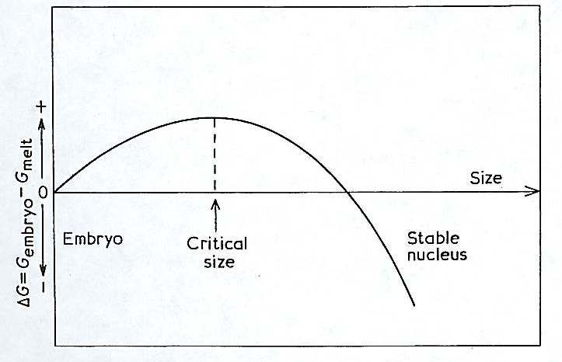
When the embryo is small, the surface area to volume ratio of the embryo is large, resulting in a larger Gibbs free energy cause by the surface energy of the embryo. The process then reaches a point where a critical embryo size is reached, and the Gibbs free energy begins to decrease as a result of the incorporation of more molecules into the embryo (thus reducing the surface to volume ratio). Once this critical size is reached, the molecule will grow spontaneously. Eventually, the embryo will reach a size where it becomes stable and the Gibbs free energy is less than that of the melt. The peak in the above figure is an energy barrier that must be overcome to have stable nuclei. It is envisioned that at the crystallization temperature, there is enough thermal energy for this barrier to be overcome.

A key issue with comparing the nucleation of small molecules and polymers are the geometries of the embryos. In its simplest form, the previous discussion of nucleation can be applied to a spherical entity, where asymmetries and variations in surface energies can be neglected. Polymer scientists are unfortunate in that they can not ignore such issues. The theories of polymer crystallization envisage the growth taking place via a secondary nucleation process from the face of a pre-existing crystal surface. The following figure shows such a process:
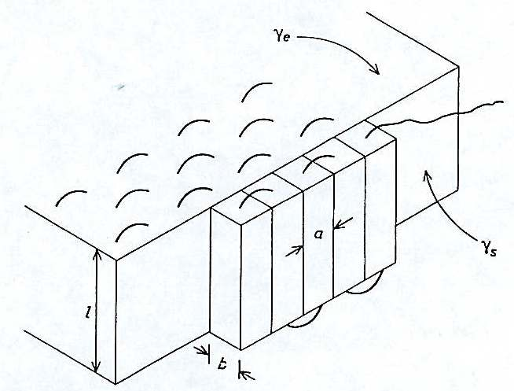
The new polymer crystals add to a molecularly smooth surface, which is similar to the previously discussed primary nucleation process, but differs in that less surface area per volume is created. This mean the energy barrier is lower for this type of process. This secondary nucleation process can be described in a series of steps:
- a molecular strand lays down on an otherwise smooth crystal surface
- for freely rotating, flexible molecules*, further segments are subsequently added via the chain folding process
*rigid molecules for extended chains
The energies associated with this process include the surface energy of the folds (γ_{e}), the surface energy of the lateral surface (γ_{s}), and the free energy change of crystallization per unit volume (ΔG_{v}).

The increase in surface free energy involved in laying down n adjacent molecular strands of length l is:
$${ΔG}_{n}=2\text{bl}γ_{s}+2\text{nab}γ_{e}$$
Where the cross section of the strand is a*b.

Combating this increase in ΔG from the additional surface energy is the reduction in ΔG due to the incorporation of molecular strands in the crystal, given by:
$${ΔG}_{n}=−\text{nabl}{ΔG}_{v}$$
Balancing these two equations gives:
$${ΔG}_{n}=2\text{bl}γ_{s}+2\text{nab}γ_{e}−\text{nabl}{ΔG}_{v}$$
At this point, we have an expression that gives the overall change in Gibbs free energy when n strands are laid down on a molecularly smooth surface.

The next step is to determine the free energy change upon crystallization per unit volume (ΔG_{v}). To do so, we recall our relationship between the Gibbs free energy and the enthalpy, temperature, and entropy of a system from thermodynamics. First, we assume that the polymer crystal has an equilibrium melting temperature (T⁰_{M}), which is the temperature at which a crystal without any surface area melts (i.e. the melting temperature of a “perfect” crystal). We can then state:
$${ΔG}_{v}={ΔH}_{v}−{TΔS}_{v}$$
Where ΔH_{v} and ΔS_{v} are the enthalpy and entropy of fusion per unit volume.

At T⁰_{M}, there is no change in the Gibbs free energy since melting and crystallization are equally probable, so ΔG_{v} is equal to zero at this temperature, resulting in:
$${ΔS}_{v}=\frac{{ΔH}_{v}}{T_{m}^{0}}$$
When crystallization occurs below this equilibrium melting temperature, we can approximate ΔG_{v} by substituting the above expression for ΔS_{v} into the general equation for the Gibbs free energy, giving:
$${ΔG}_{v}={ΔH}_{v}−\frac{{TΔH}_{v}}{T_{m}^{0}}$$
We are typically interested in the degree of undercooling, which is defined as:
$$ΔT=T_{m}^{0}−T$$
Which upon substitution gives:
$${ΔG}_{v}=\frac{{ΔTΔH}_{v}}{T_{m}^{0}}$$
Substitution this equation into the overall Gibbs free energy equation previously derived, and simplifying by stating that 2bsγ_{s} is relatively small compared to the other components in the equation, we derive a relationship between the lamella thickness and the undercooling:
$$l≈\frac{2γ_{e}T_{m}^{0}}{{ΔTΔH}_{v}}$$
This relationship (also known as the Hoffman equation) shows that large supercooling results in thinner lamellae.

The Avrami model – percent crystallinity with respect to process time
As mentioned in the introduction, the Avrami equation is based on empirical data that relates the percent crystallinity (X_{c}) to time (t). As we will see, additional information can also be obtained from fitting data to the Avrami relationship, including an understanding of the crystallization process (instantaneous or sporadic) and the geometry of the crystallite formed (rod, disc, sphere, sheaf).

The Avrami equation is:
$$\text{ln}(1−X_{c})={\text{kt}}^{n}$$
Where X_{c} is the volume fraction of crystallinity, t is the time, k is a scaling constant, and n is the Avrami constant. The following plot is typical of an Avrami analysis, with the relative crystallinity versus time.
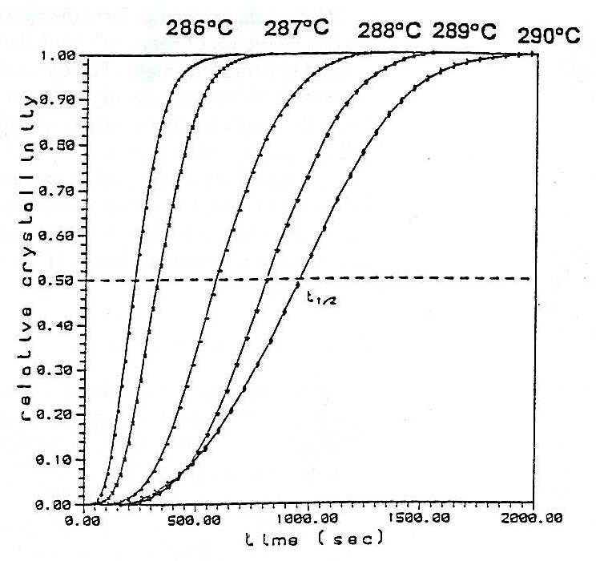
At this point, we want to discuss in greater detail the importance of the Avrami constant. The value of the Avrami constant gives insight to the nucleation process and the shape of the growing entity. Instantaneous (heterogeneous) or sporadic (homogeneous) nucleation give different time dependencies because of the time dependence. The assumption of a disc or sphere as the growing entity also gives different powers of time dependence because of the different dimensionalities of the object. The following table gives a list of Avrami exponents and their morphologies:

Morphology | Instantaneous  (Heterogeneous) | Sporadic  (Homogeneous)
Rod | 1 | 2
Disc | 2 | 3
Sphere | 3 | 4
Sheaf | 5 | 6
Table 1. A tabulation of Avrami constant (n) relative to nucleation process and growth geometry.

To analyze the Avrami equation, the following form is generally used:
$$\text{ln}(\text{ln}(1−X_{c})=\text{ln}k+n\text{ln}t$$
And a plot of ln(ln(1-X_{c})) vs. t is generally made, as shown in the following figure.
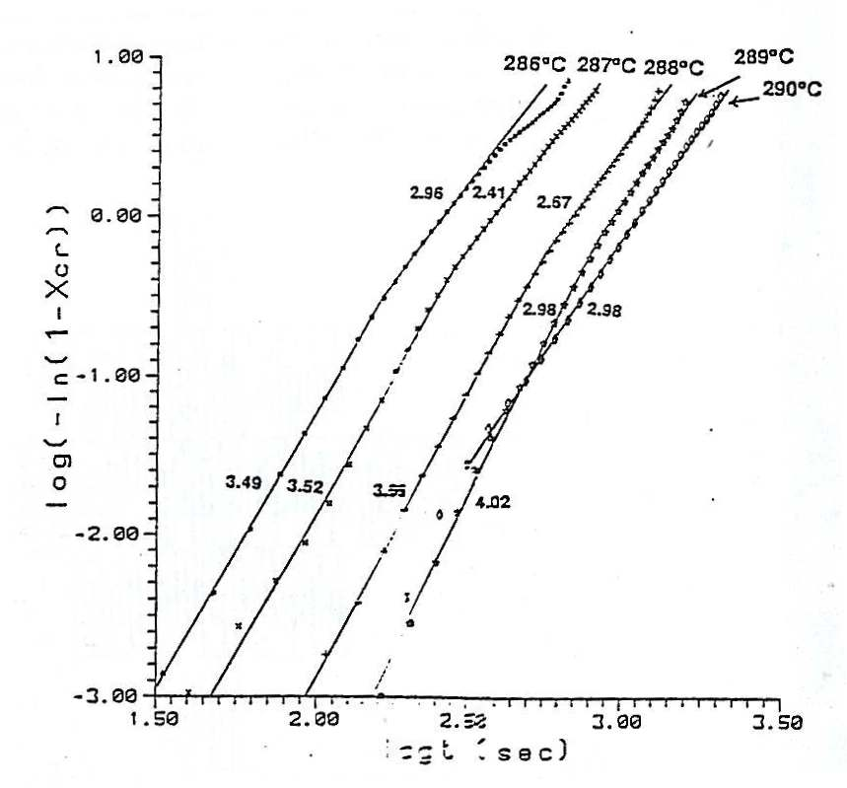
The slope of the line gives the Avrami constant (n), which with some knowledge of the nucleation step, can provide insight into the geometry of the crystal. In contrast, if microscopy techniques are employed (such as TEM, SEM, or AFM) to understand the geometry of the crystal, information regarding the nucleation process can be derived. Generally, a mixture of instantaneous and sporadic nucleation occurs, with the Avrami constant being non-integer. In closer examination of the above figure, one notices a second regime at higher time that has a smaller n (lower slope). This is likely due to the effects of secondary crystallization that occurs after the impingement of the spherulites. The intersection of these two sections is indicative of an approximate average impingement time for the spherulites during the crystallization process.

While the Avrami analysis that has been described gives insight into the crystal morphology being developed and the nucleation process with which it has been initiated, it does not provide any insight into the actual growth rates of the crystals. This analysis can be easily conducted with the Avrami data by conducting a study under various crystallization temperatures and measuring the volume fraction of crystallinity. This introduces the concept of half-time, which is the time required for the volume fraction of crystallinity to reach 50%. To analyze the data for a rate study, one plots the reciprocal of the half-time versus the reciprocal of the supercooling. For an instantaneous process, a linear relationship is seen between the reciprocal to the half time and the reciprocal of the supercooling. For sporadic nucleation, a linear relationship is seen when plotting the reciprocal of the half time versus the reciprocal of the square of the supercooling.

